**Kubernetes Cluster’s on Cloud**

For production purposes there are many ways to get started with a kubernetes cluster both in private or public cloud environment. I would categorize them as self-hosted or turnkey solutions and hosted or managed solutions. 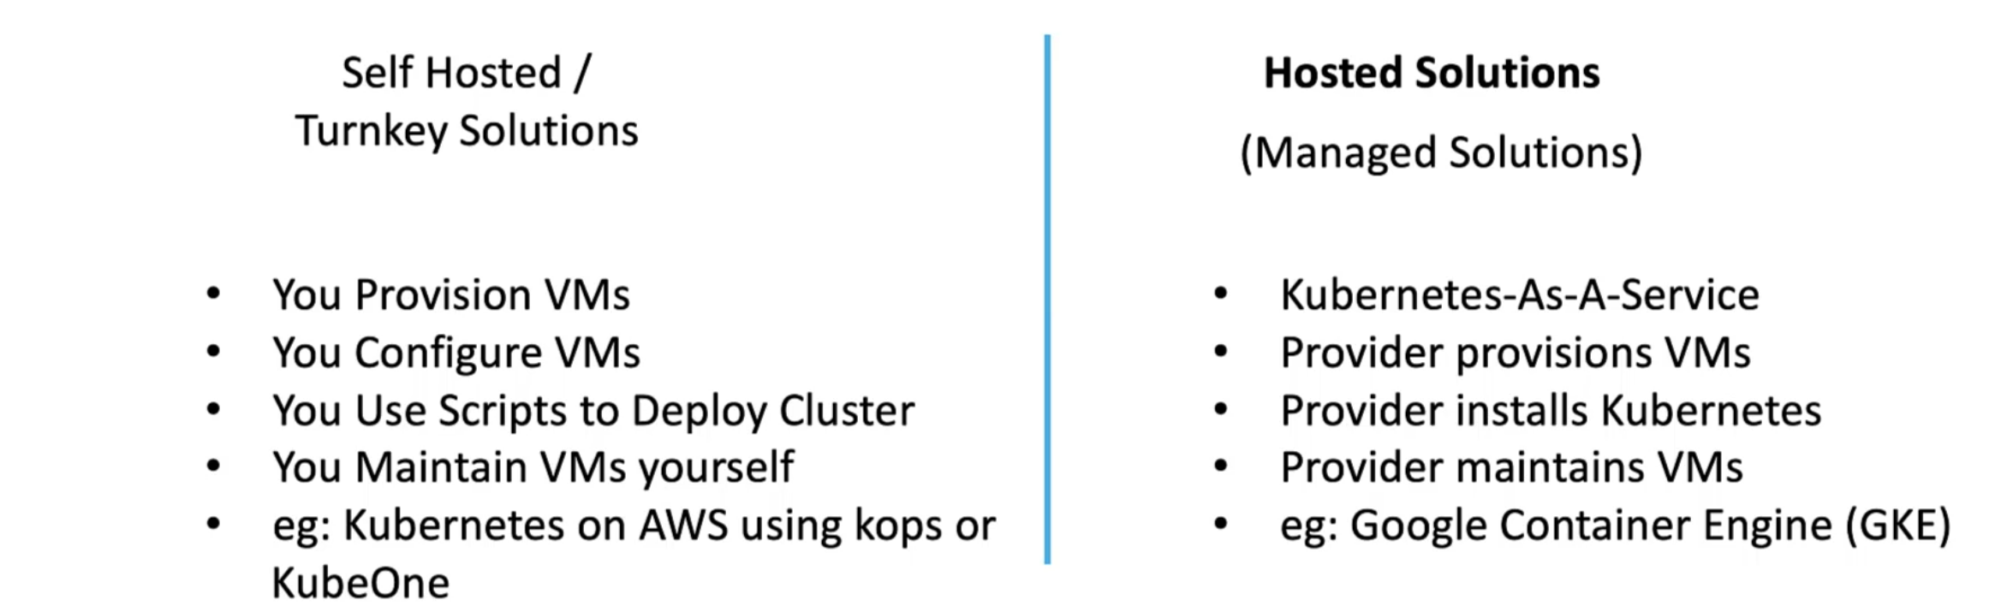

**Turnkey Solutions:**

Turnkey solutions, where you will provision and configure required VMs. Use some tools or scripts to configure the K8s cluster on them. At the end of the day, you are responsible for maintaining those VMs and patching them and upgrading them, etc.

But, Provisioning the cluster itself and managing the life cycle of the cluster are made easy using certain tools and scripts.

For example, dpeloying K8s cluster on AWS can be made easy using tools like Kops or KubeOne, etc.

**Hosted Solutions:**

Hosted solutions are more like Kubernetes-as-a-service solution. The cluster along with the required VMs are deployed by the provider, and K8 is configured by them by the provider. The VMs are maintained by the provider.

For Example, Google Conatiner Engine or the Google Kubernetes Engine (GKE) lets you provision a K8s cluster in a matter of minutes with just a few clicks without having to perform any kinf of configuration by yourself.

In these environments, mostly you won’t have access to the master nodes, don’t have access to the VMs themselves, to perform any kind of configuration changes on the master nodes. The version of Kubernetes and the master nodes are all managed by the provider. 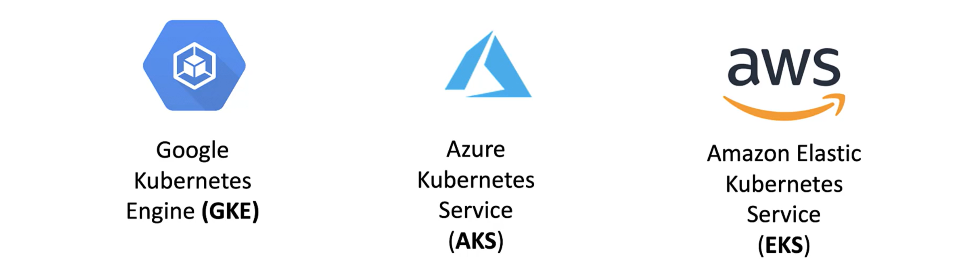

In the section we will look at deploying our example voting app on GKE, AKS, EKS.

**Kubernetes on GCP (GKE):**

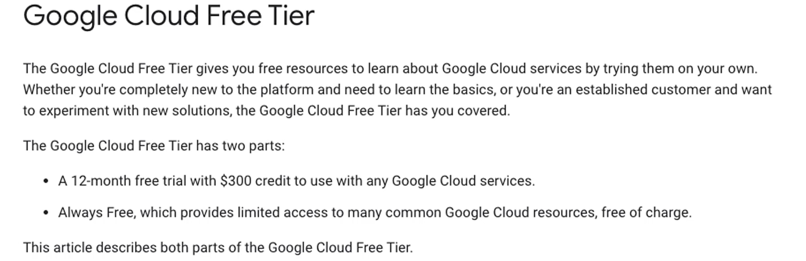

**Link:** <https://cloud.google.com/free/docs/free-cloud-features>

Create a free tier account to try deploying voting app on GCPs GKE. Once free-tier account is created this is how the dashboard of GCP looks like.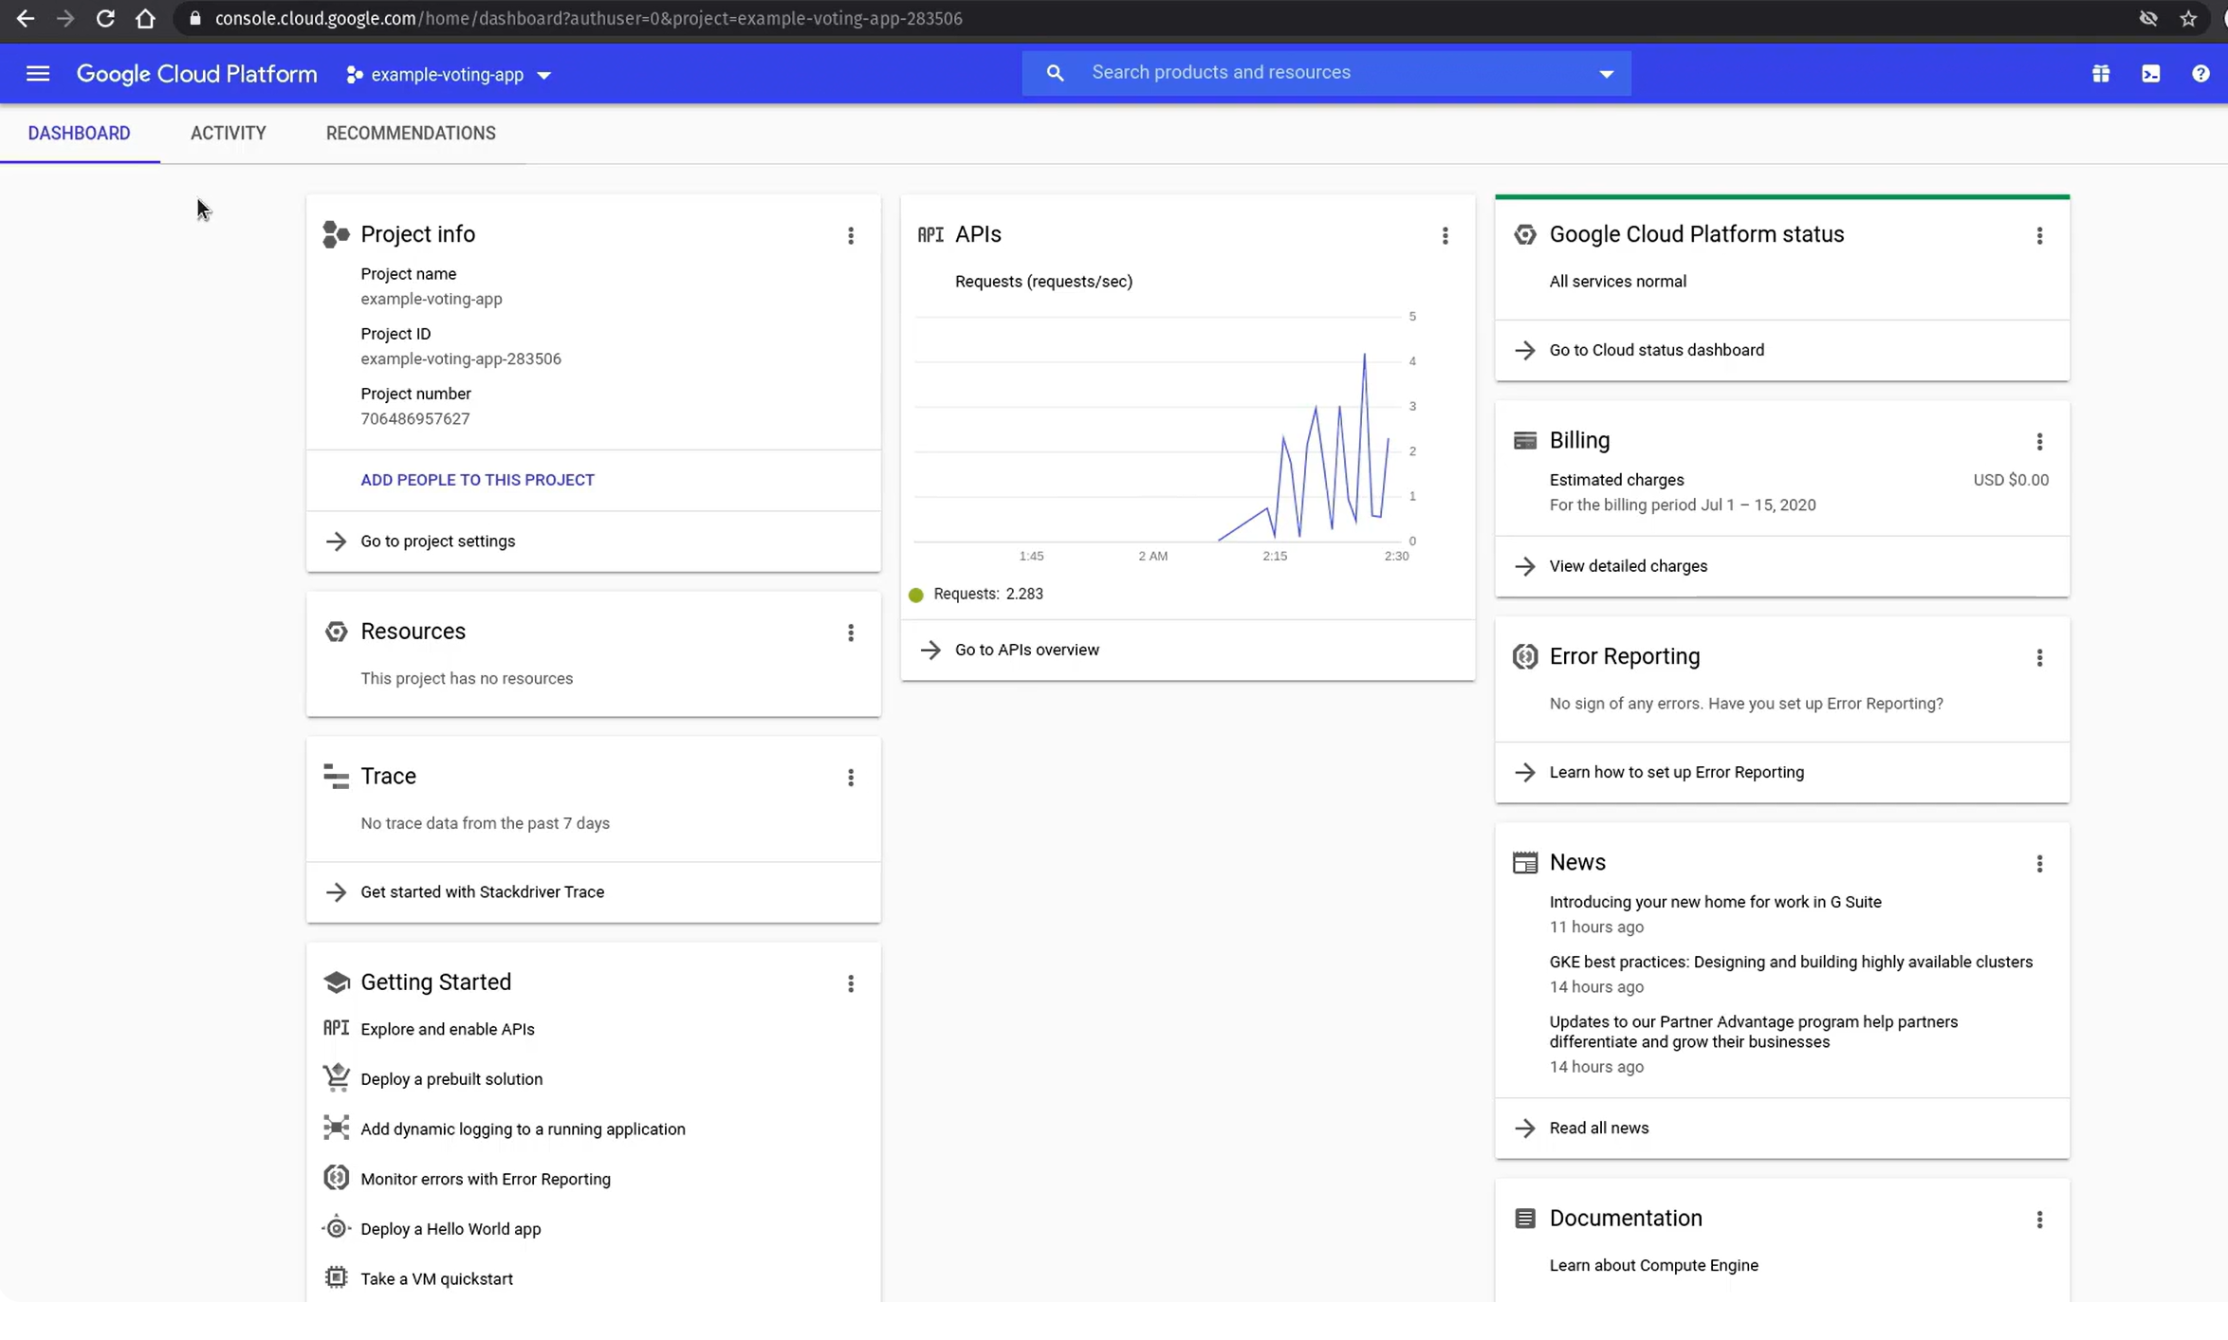On the left side, click on the three lines and check the **Kubernetes Engine** under Compute Section. Click on that. Then Click on Clusters 🡪 Create Cluster. 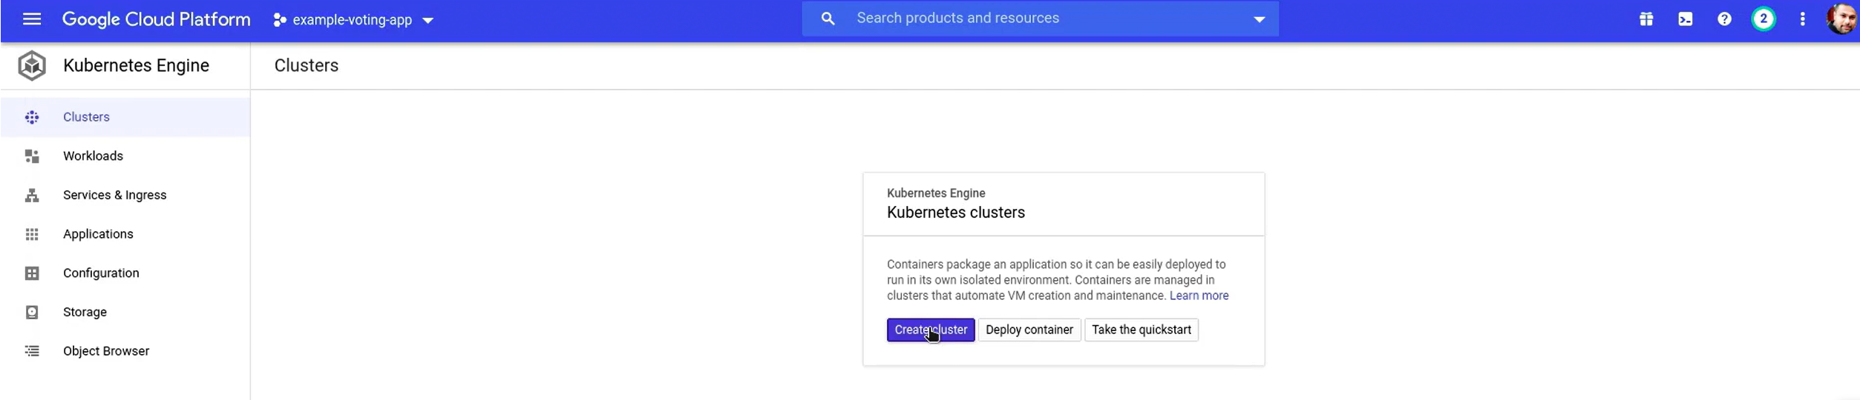This will load the K8s cluster creation interface. Just change the name and rest all options go with default values.

For Master version, if you want to get auto updated then select Release channel. If you select Static version, you can pick any version of your choice and you have to manually update it.

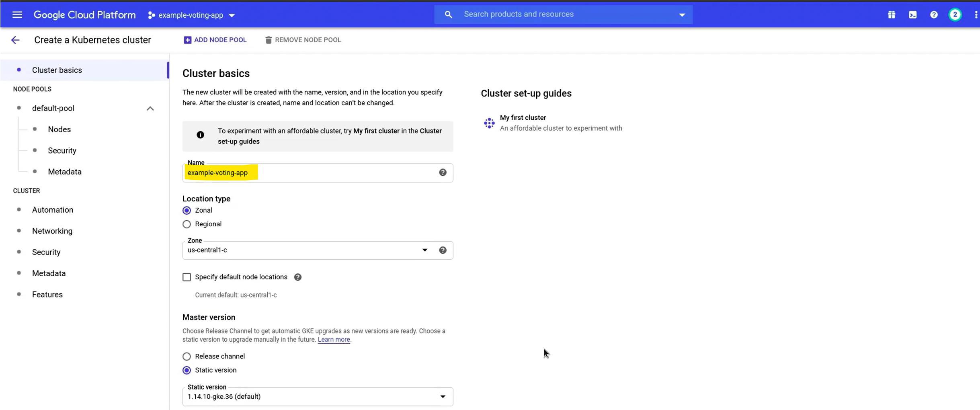 You can click on Nodes and make changes to the type of VM to be used, size, etc. But, for all the things we are going with default values. Now, click on Create button at the bottom of the screen.

This will take some 10 minutes of time to create. 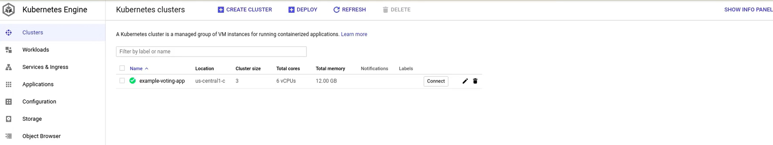

Now, the cluster is setup. Clicking on connect button you can connect to the cluster using cloud shell. Select “Run in Cloud Shell”. Cloud Shell opens at the bottom of the screen. Scroll it to the top. 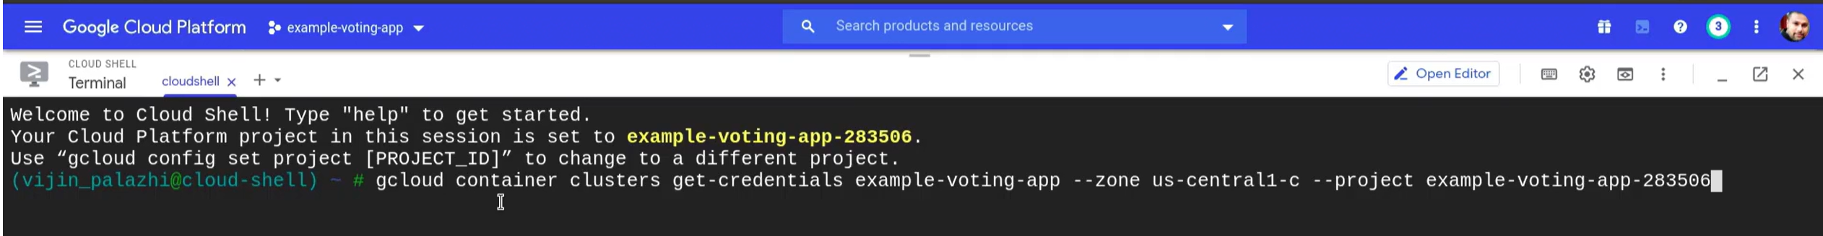The command above will enable the kubectl talk to the GKE cluster. In cloud shell we already had kubectl utility installed. So, run the above command to setup GKE Cluster. Once that is done, we are in ready state to go further. You have three nodes in the cluster.

Original Git repo for Voting app: <https://github.com/dockersamples/example-voting-app>

KodeKloud repo: <https://github.com/kodekloudhub/example-voting-app> In this repo you can go to K8s-specifications folder to get all the deployment and service YAML files. Same folder and files were there in Orginal git repo from first URL. But continue with second repo as there are some changes done to complete this project.

Clone this second repo into K8 cluster in GCP. 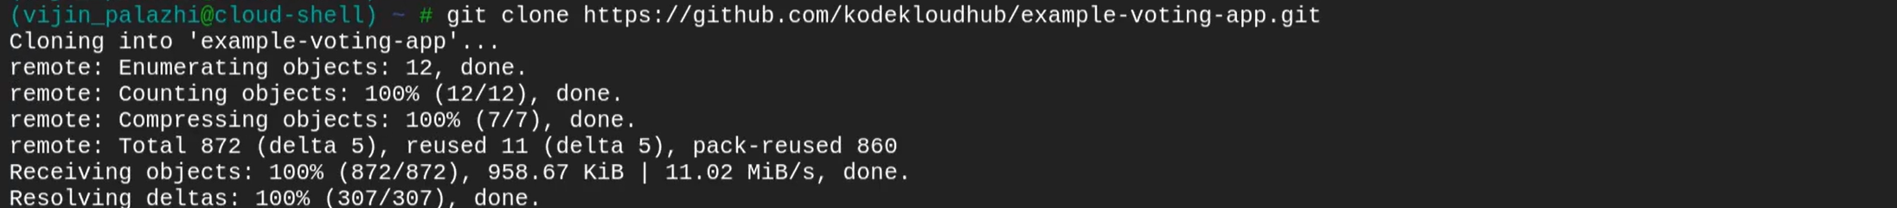Change the path to K8s-specification folder ot see the YAML files.  So, to deploy these services in K8 cluster in Cloud environment, we made one change to external services YAML files. When we deploy in cloud, native load balancer will be created (This discussed earlier). 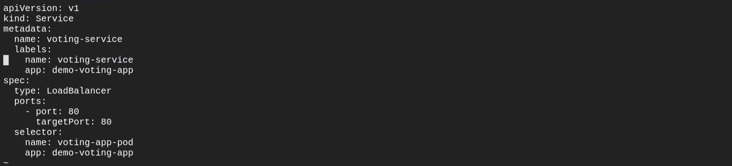So, we changes the type to **Load Balancer** instead of **NodePort.** We done the same to result-service YAML file also. 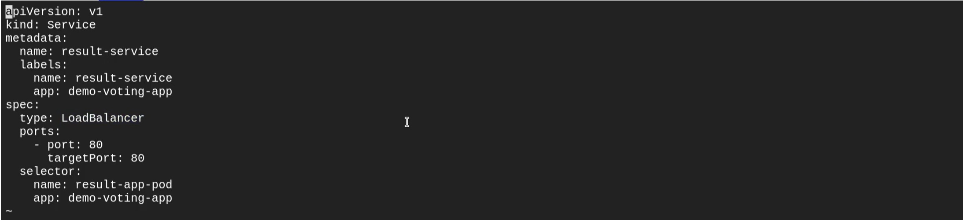Create the deployments and services.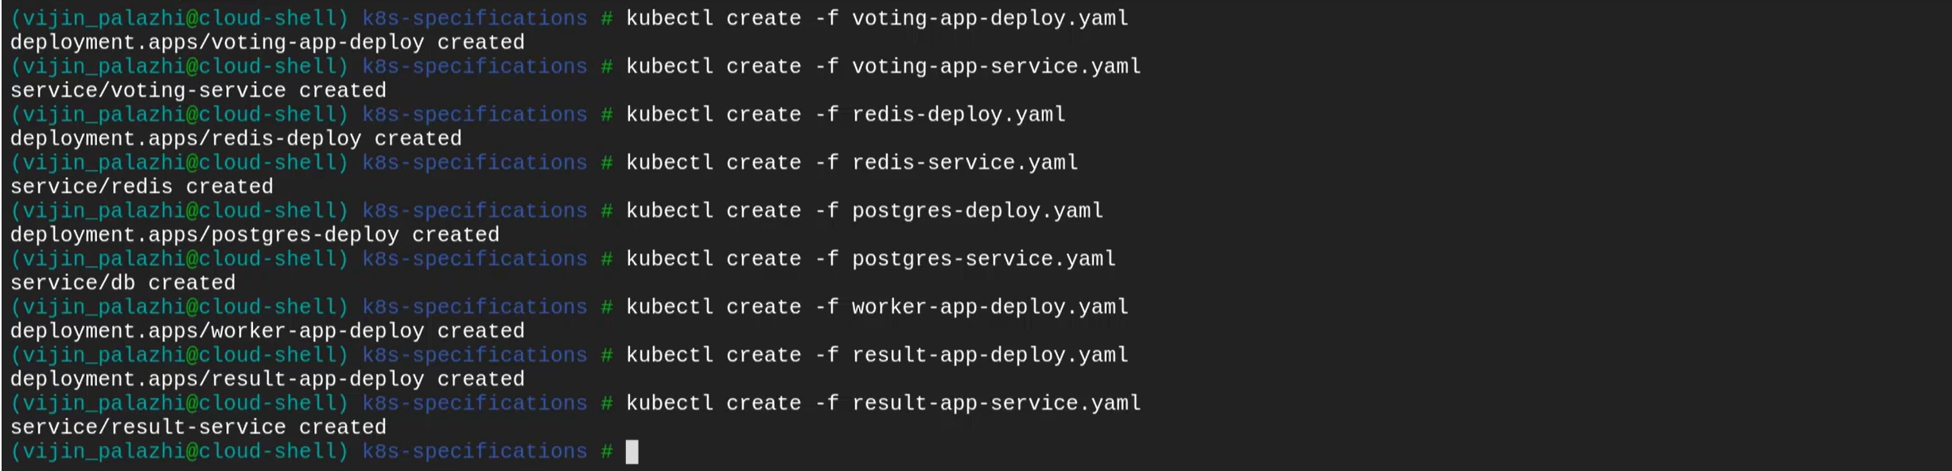Instead of giving multiple commands at once you can automate it with Bash scripting by adding all these commands into one file and executing that file.

Also, you can give **kubectl create -f . 🡪** To create all of them at once.

Now, we have all the objects created. 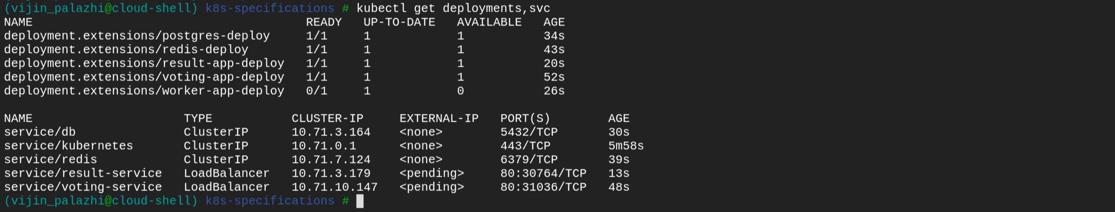We can see the Load Balancer service are still in pending state. They do not have external IP yet. In the background K8s service is working with native load balancer by sending request to native load balancer to provision a load balancer on the Google cloud platform. Once the load balancer is provisioned, we get the load balancer external IP and URL.

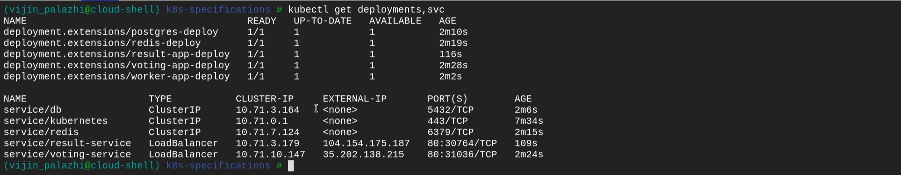Now, the load balancer are having the external IP’s available. Everything is setup now. Before we test the web site once, let’s check the load balancer configuration. 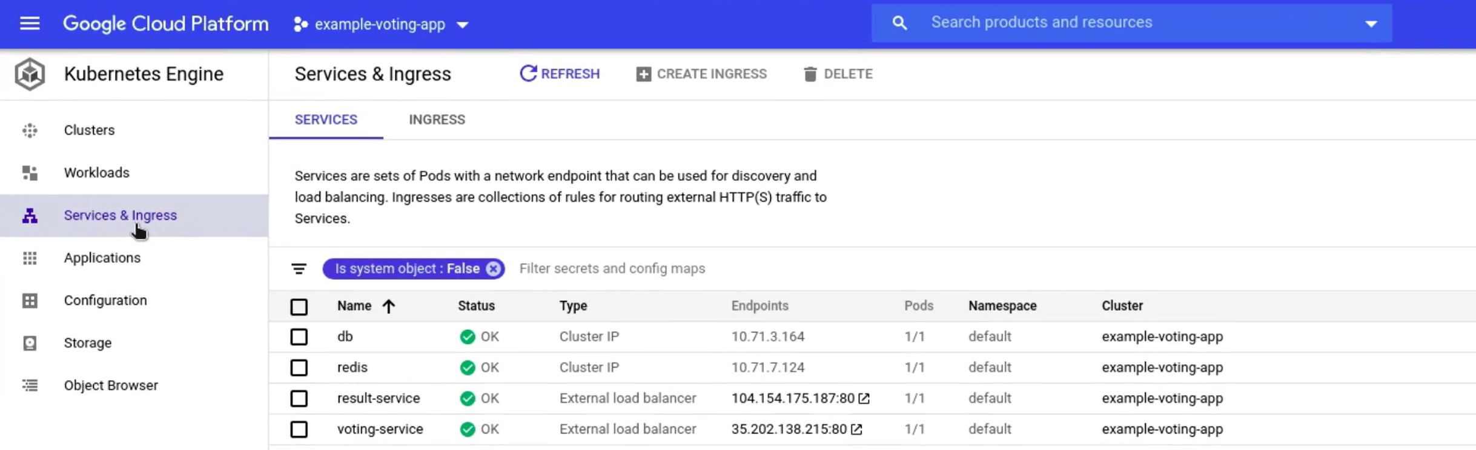Click on services tab on the left. For all services status is OK. You can see two internal services which are of type ClusterIP. And we also have two frontend services which are make using of external load balancer. And you can see the endpoints you can use to access the application. If you want to see more details you can click on any service. 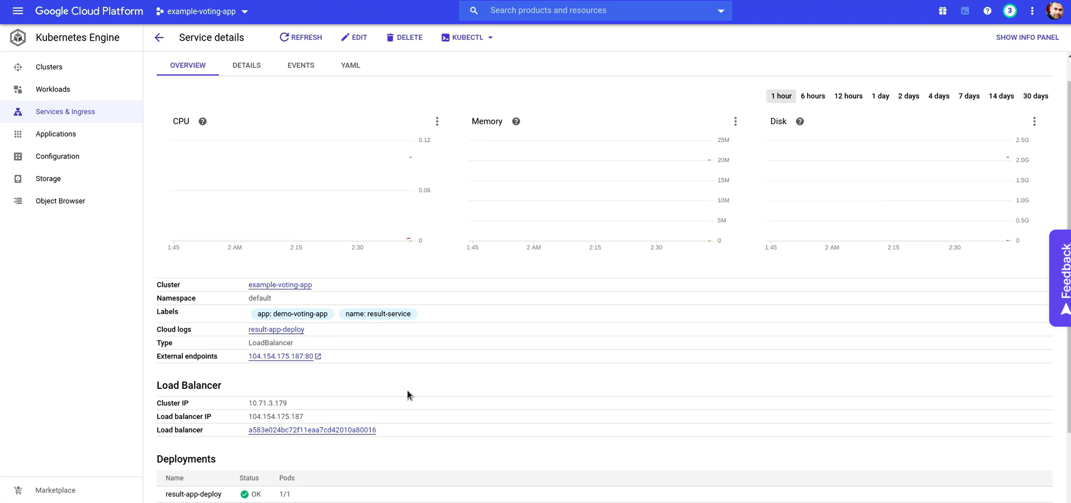Now, we can test the application. Click on Voting-service Endpoint first. 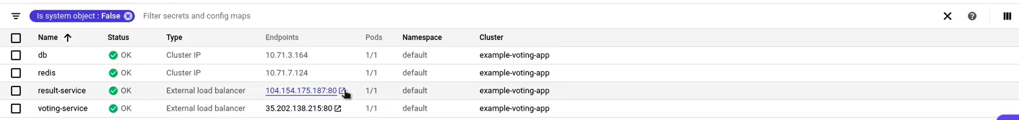It says it will re-direct to a different URL. Click on that new URL: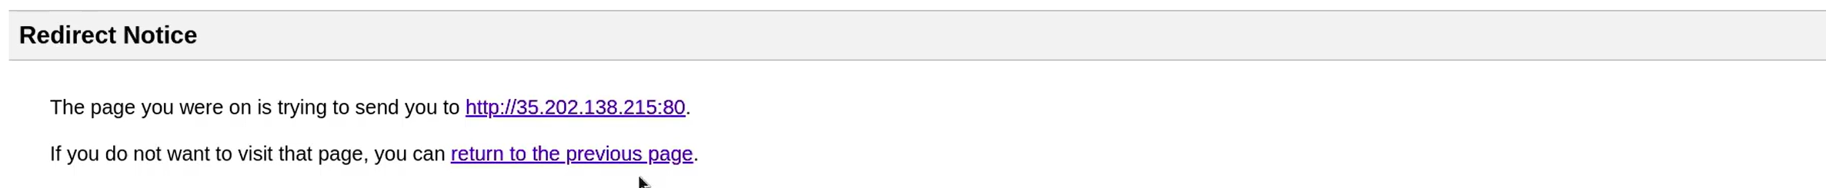 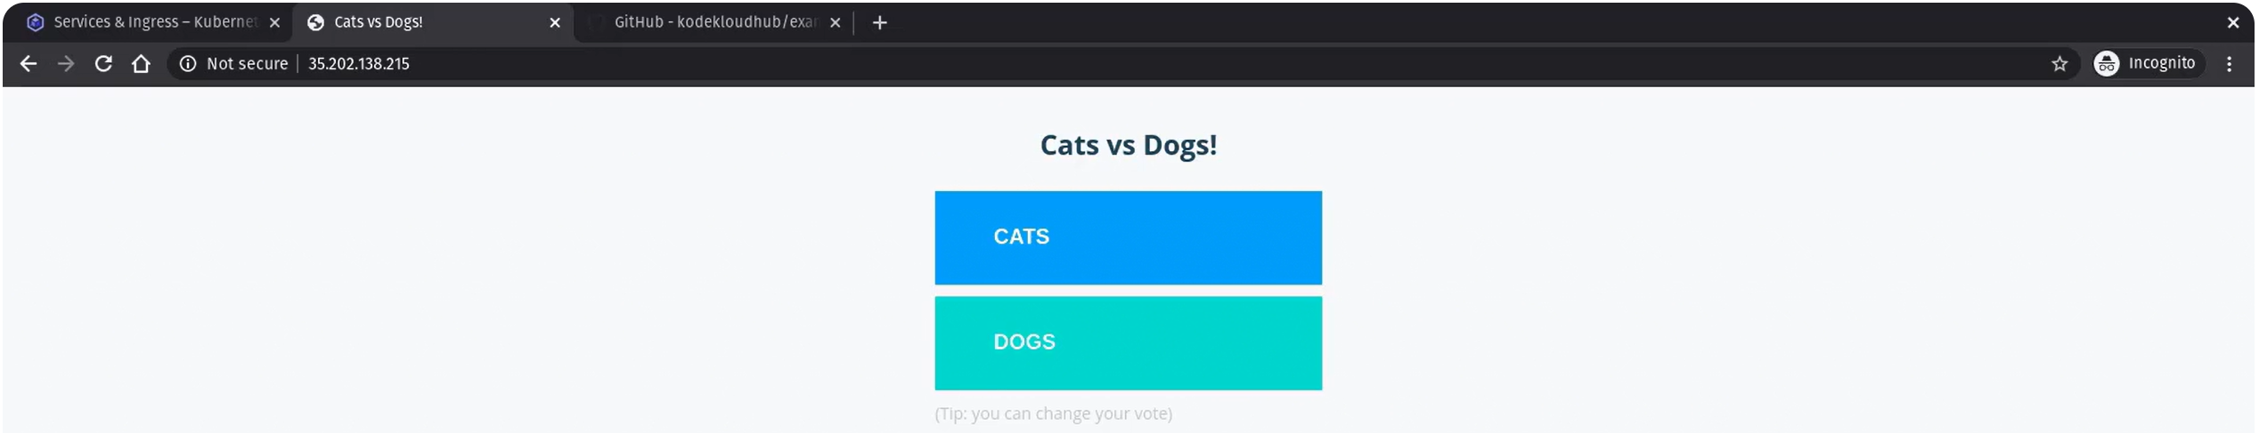This is our Voting application.

Similarly you can open the results-app as well. 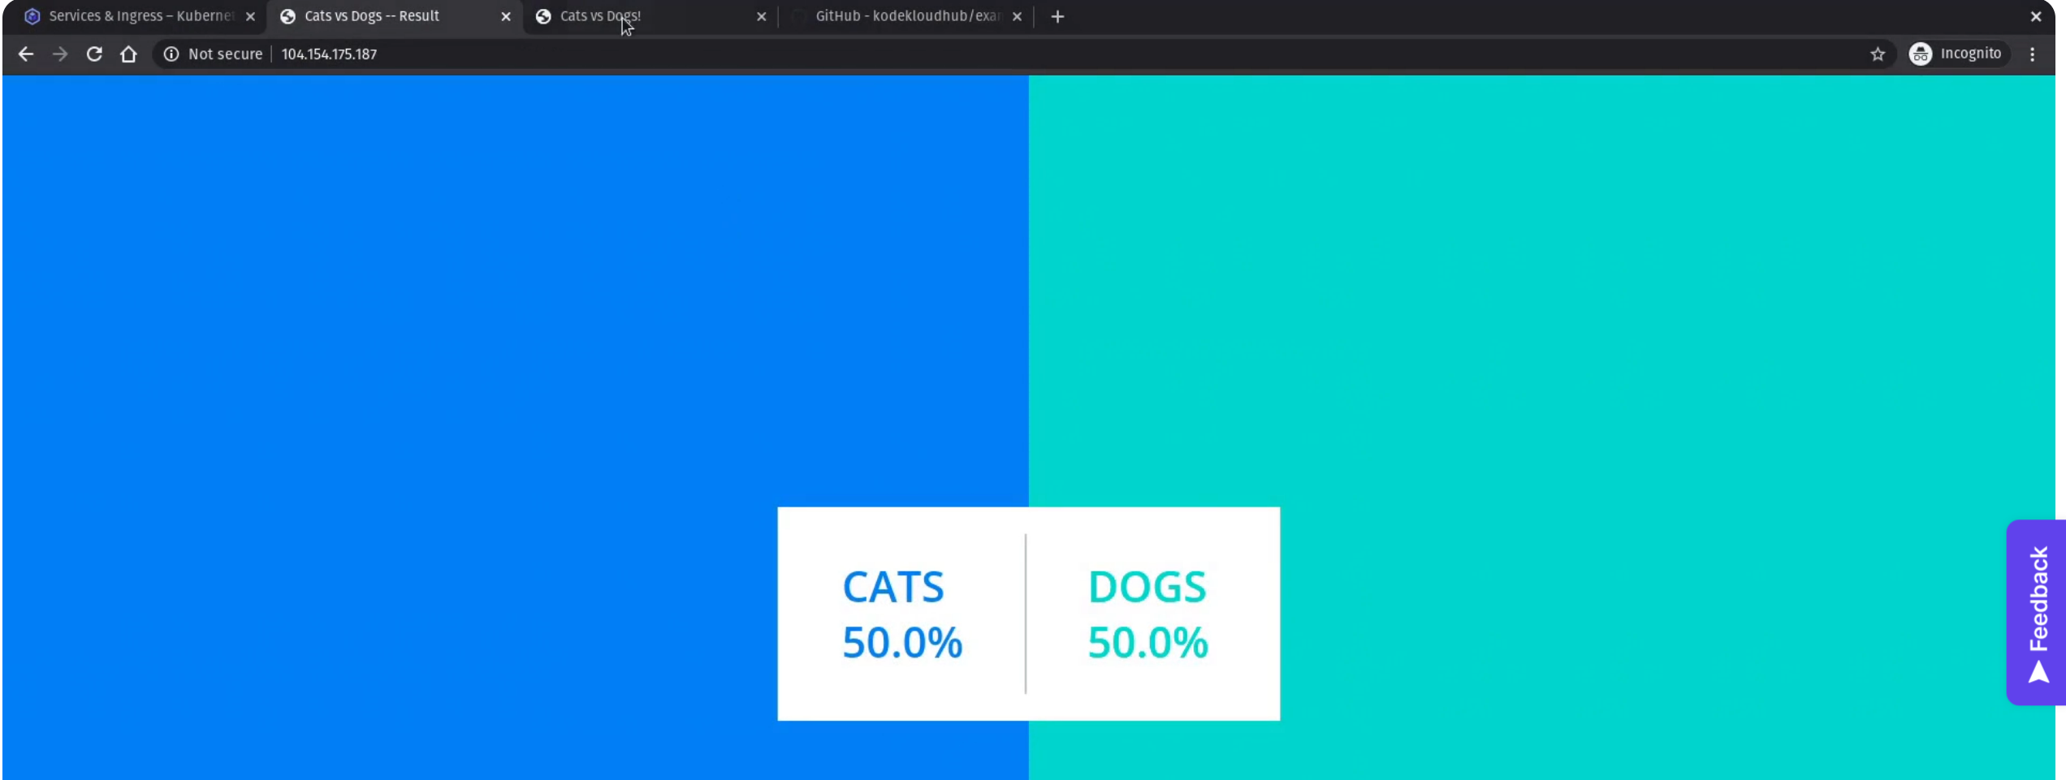Caste a vote for any one. 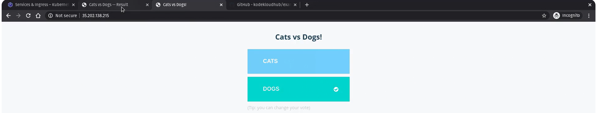Results page is updated with the vote. 

**Kubernetes on AWS (EKS):**

**Amazon Elastic Kubernetes Service (EKS)**

We are going to create an EKS Cluster which is Amazon’s managed K8s service known as Elastic Kubernetes Service. Before we begin, there are set of pre-requisites to be configured.

**Pre-Requisite:**

Create a new free AWS account.

Must have installed kubectl utility.

Configuring cluster role for EKS.

Configuring IAM role for Node group.

VPC, EC2 Key Pair which will be used to SSH to the worker nodes if you have to.

AWS Basics and AWS CLI.

**AWS Documentation on Amazon EKS:** <https://docs.aws.amazon.com/eks/latest/userguide/what-is-eks.html>

Once all the pre-requisites are setup. Search for EKS in AWS services. And give name of the cluster.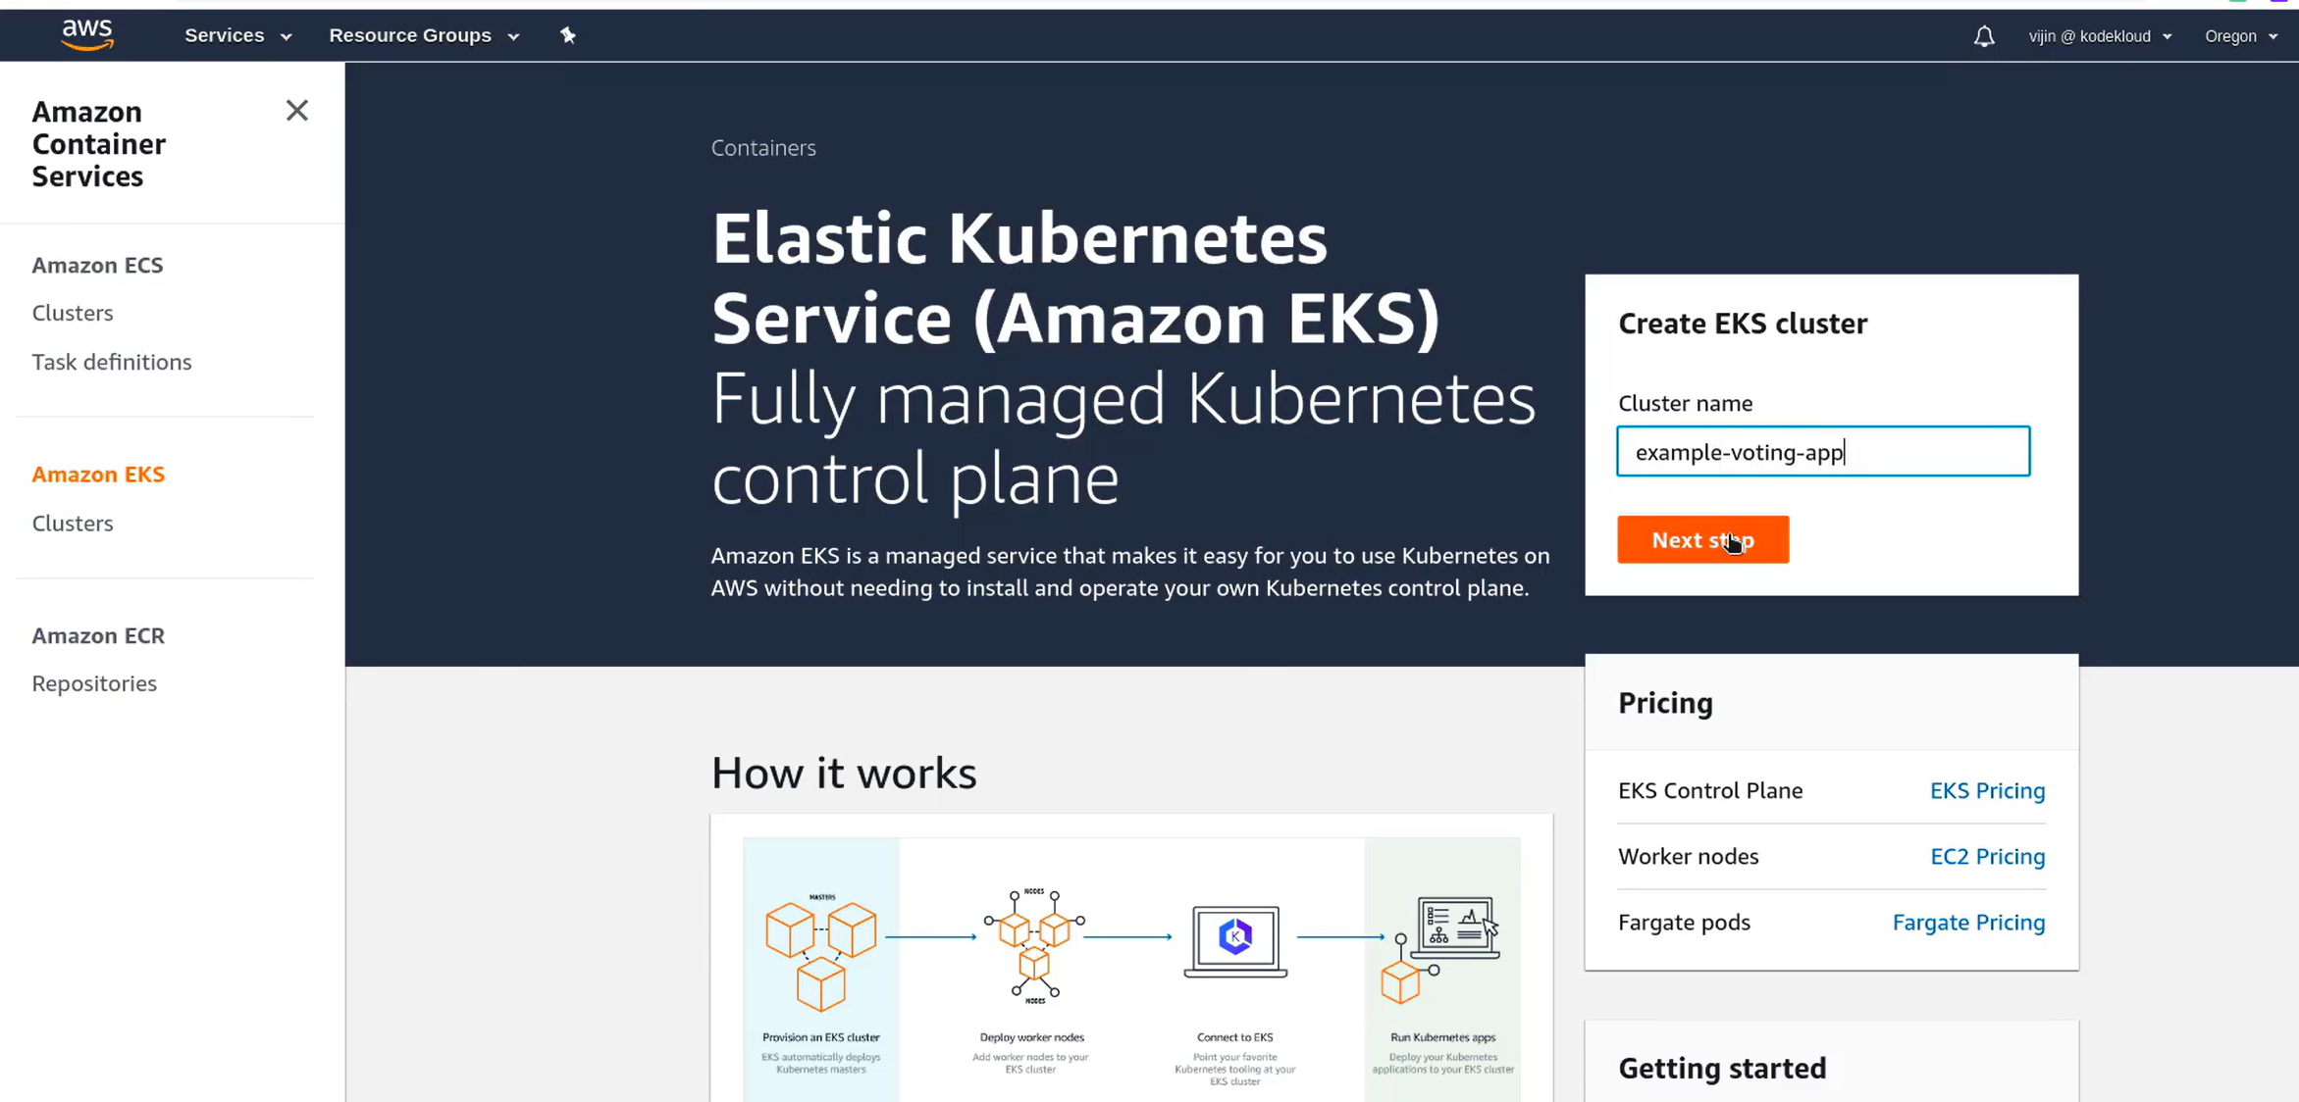Then, give the latest K8s version and select the role that is created as pre-requisite for EKS cluster. 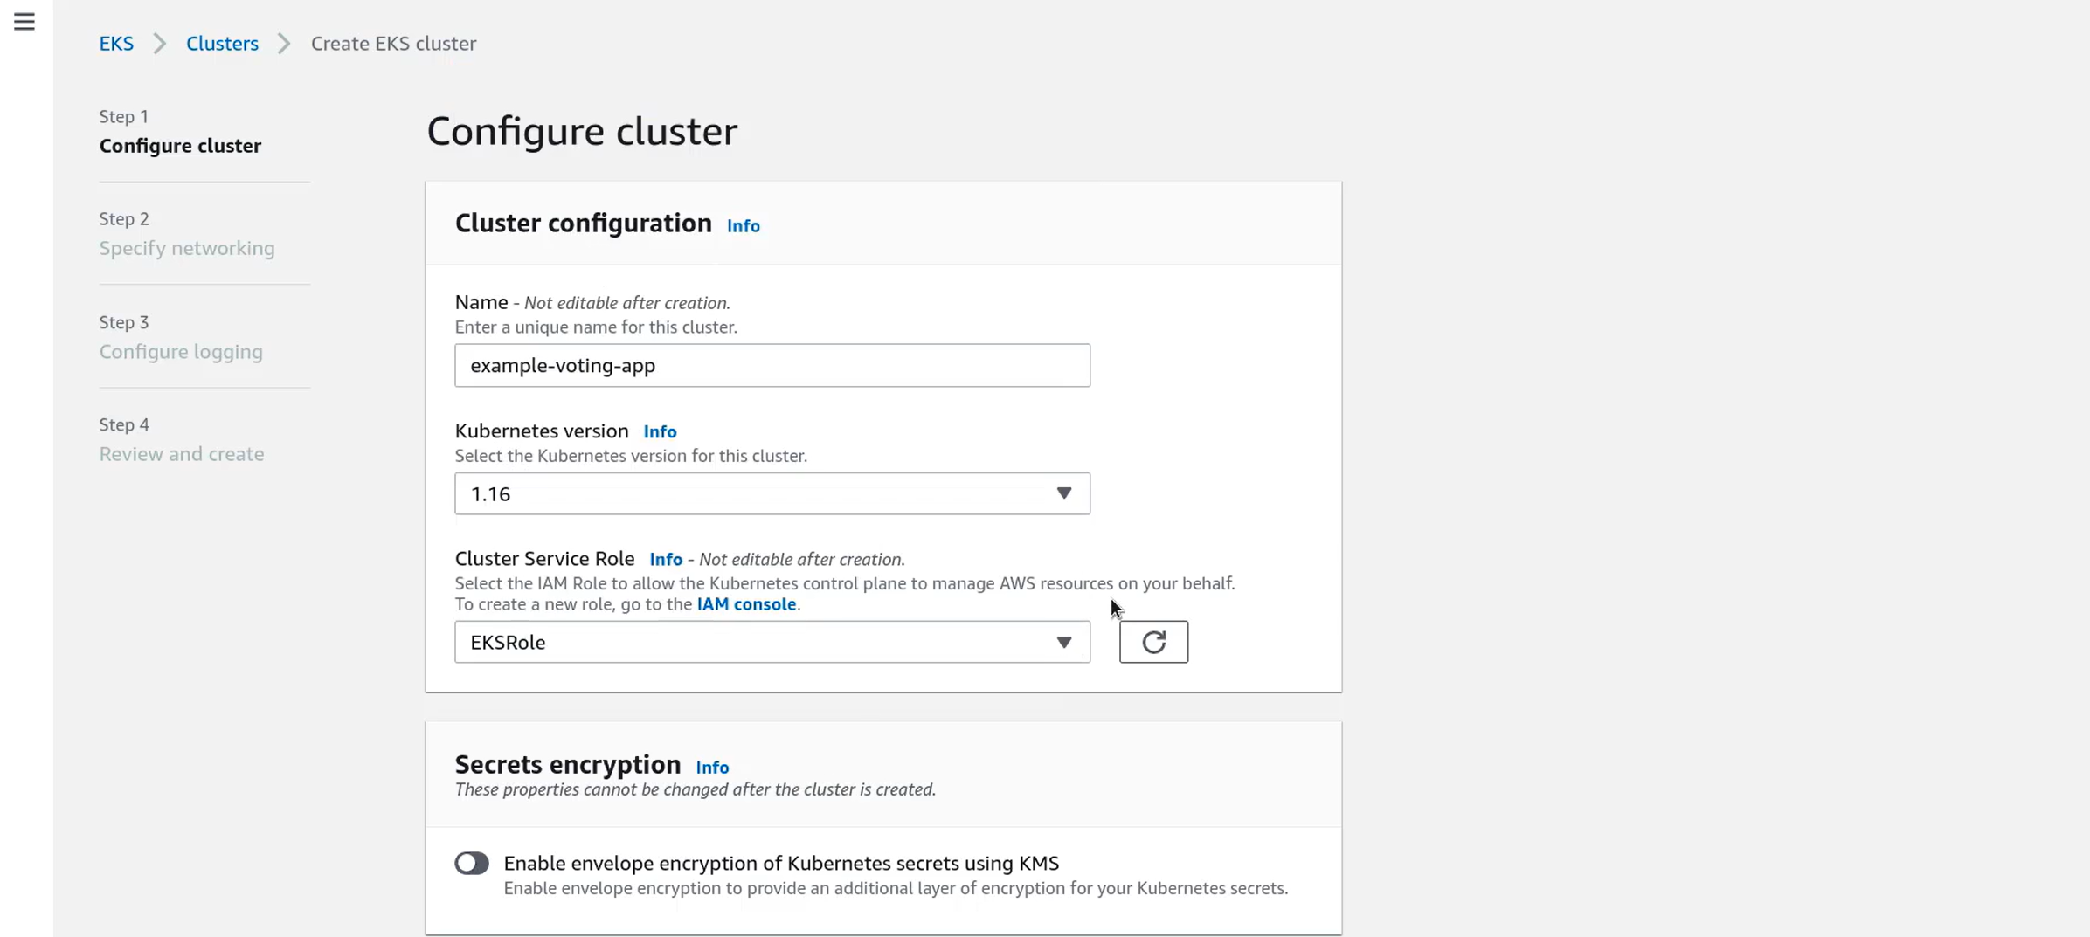Then click on next, VPC we are going with default VPC in the region and using default subnets as well. Then click on Next. 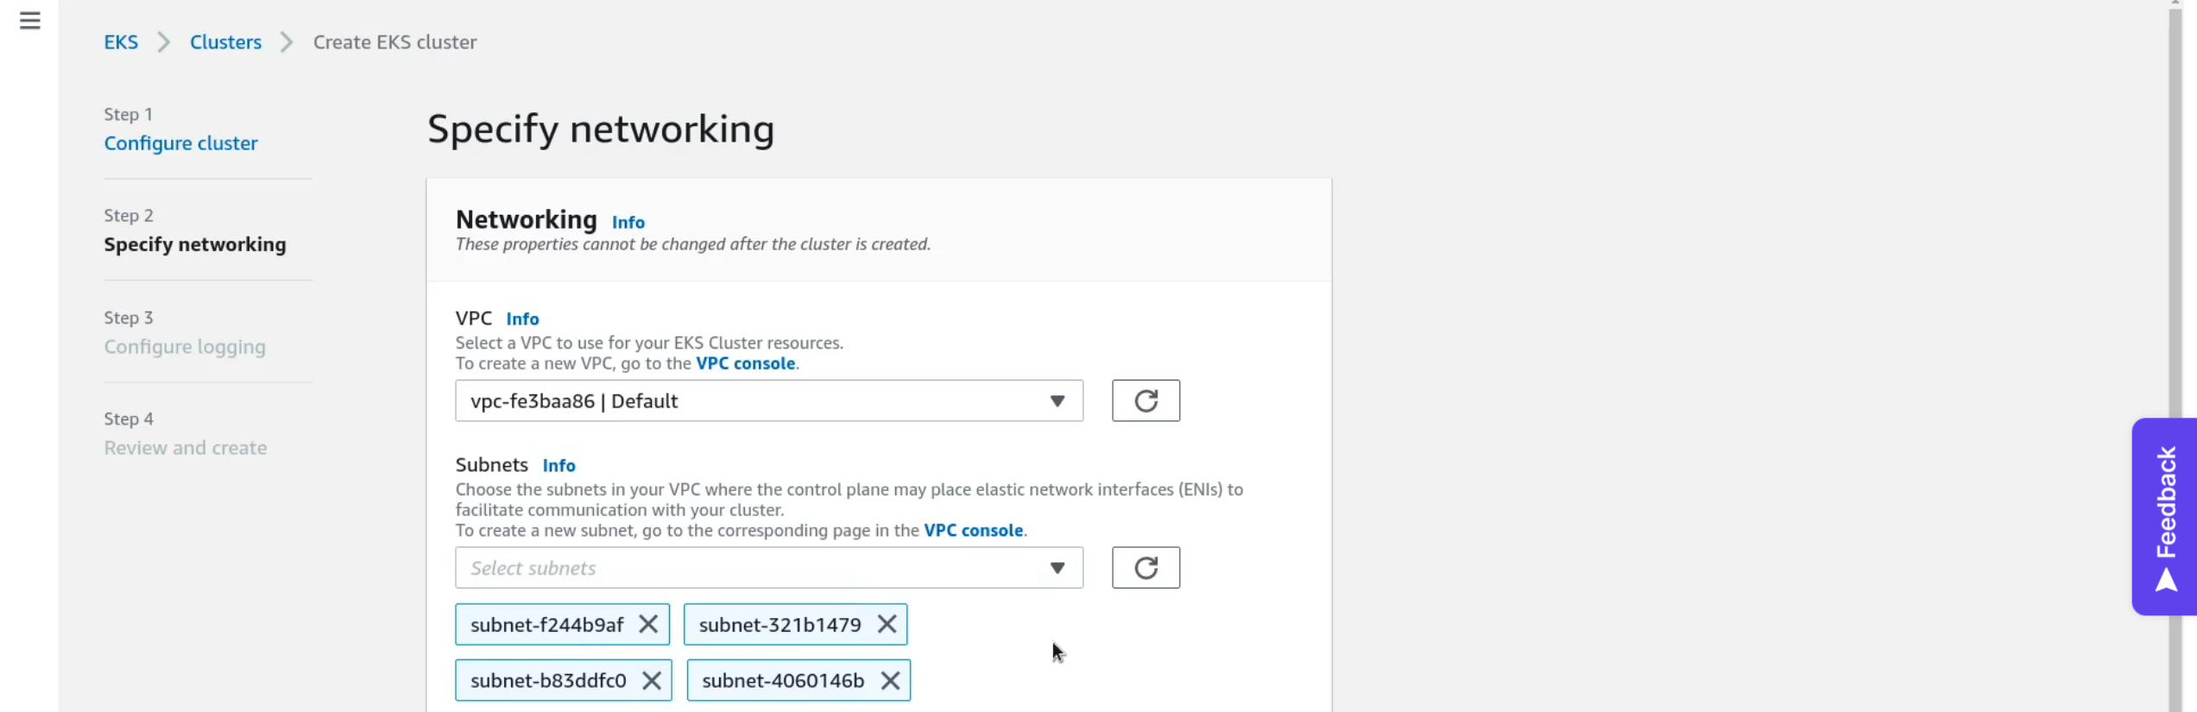Then again click on next and you will see a review page and click on **Create** button at the end of the page. This will take quite some time for this cluster to be created. 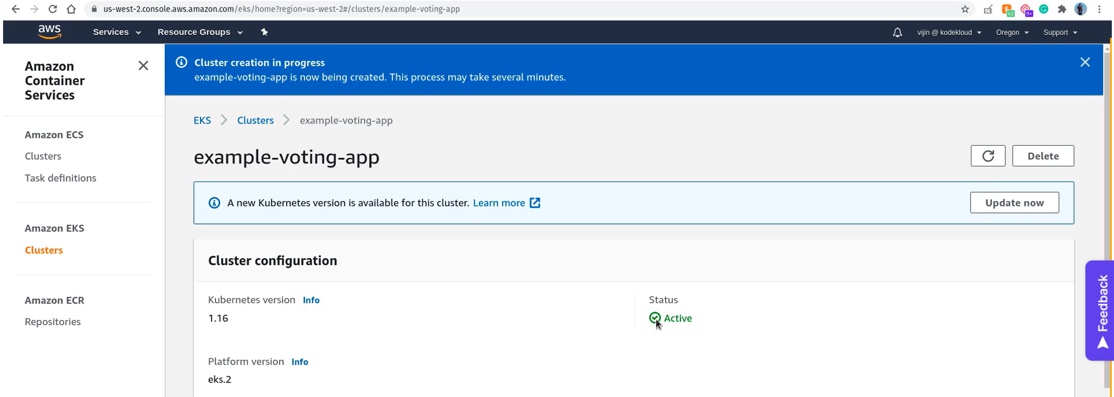Now, our cluster is created and we can Active status. Now, we need to a node group which is basically a group of worker nodes. Currently, we created a K8s cluster without nodes. In the same page go to Compute section and add click on **Add Node group.**

Assign a name for the node group. Then assign the role created for EKS Node as a pre-requisite. And for subnets we will go for default subnets. Click on refresh button next to it once, if you are not able to see any default subnets. 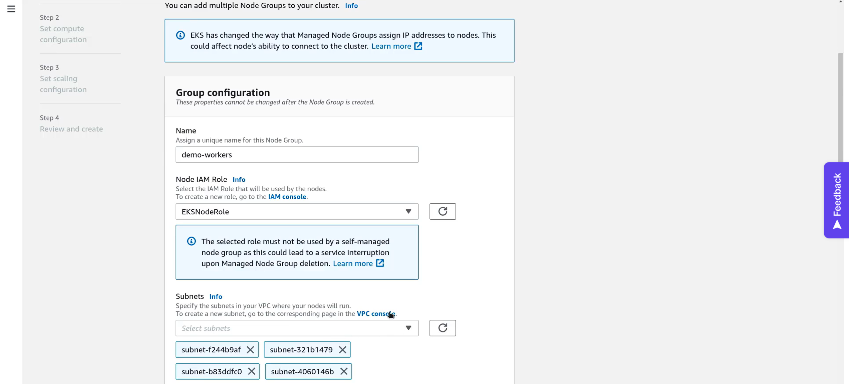Then select the SSH Key pair that is created as pre-requisite. 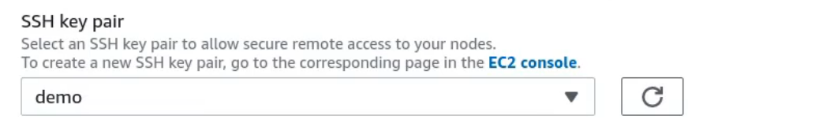

We don’t really need this unless you really want to SSH worker nodes. Then click on Next. Next, we have to set the Compute configuration. It is basically what AMI to use for worker nodes. Go with default values and click on next.

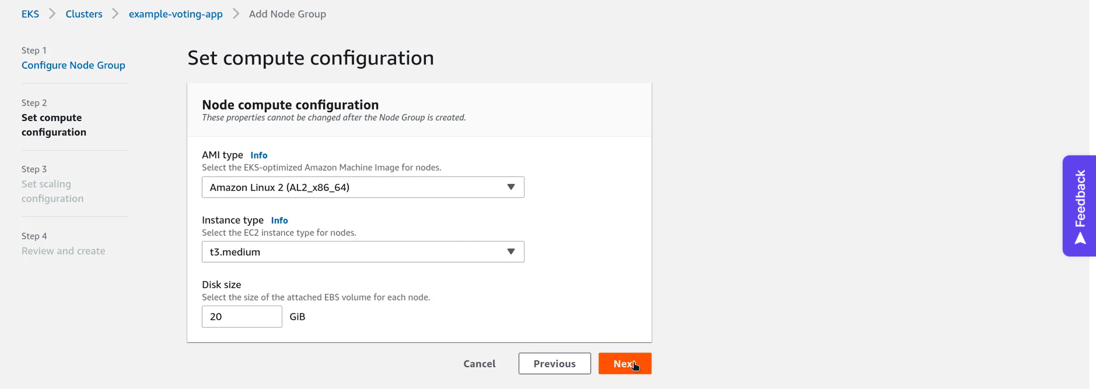Next, is scaling configuration. We will specify the number of minimum and maximum nodes and also the desired number of nodes. 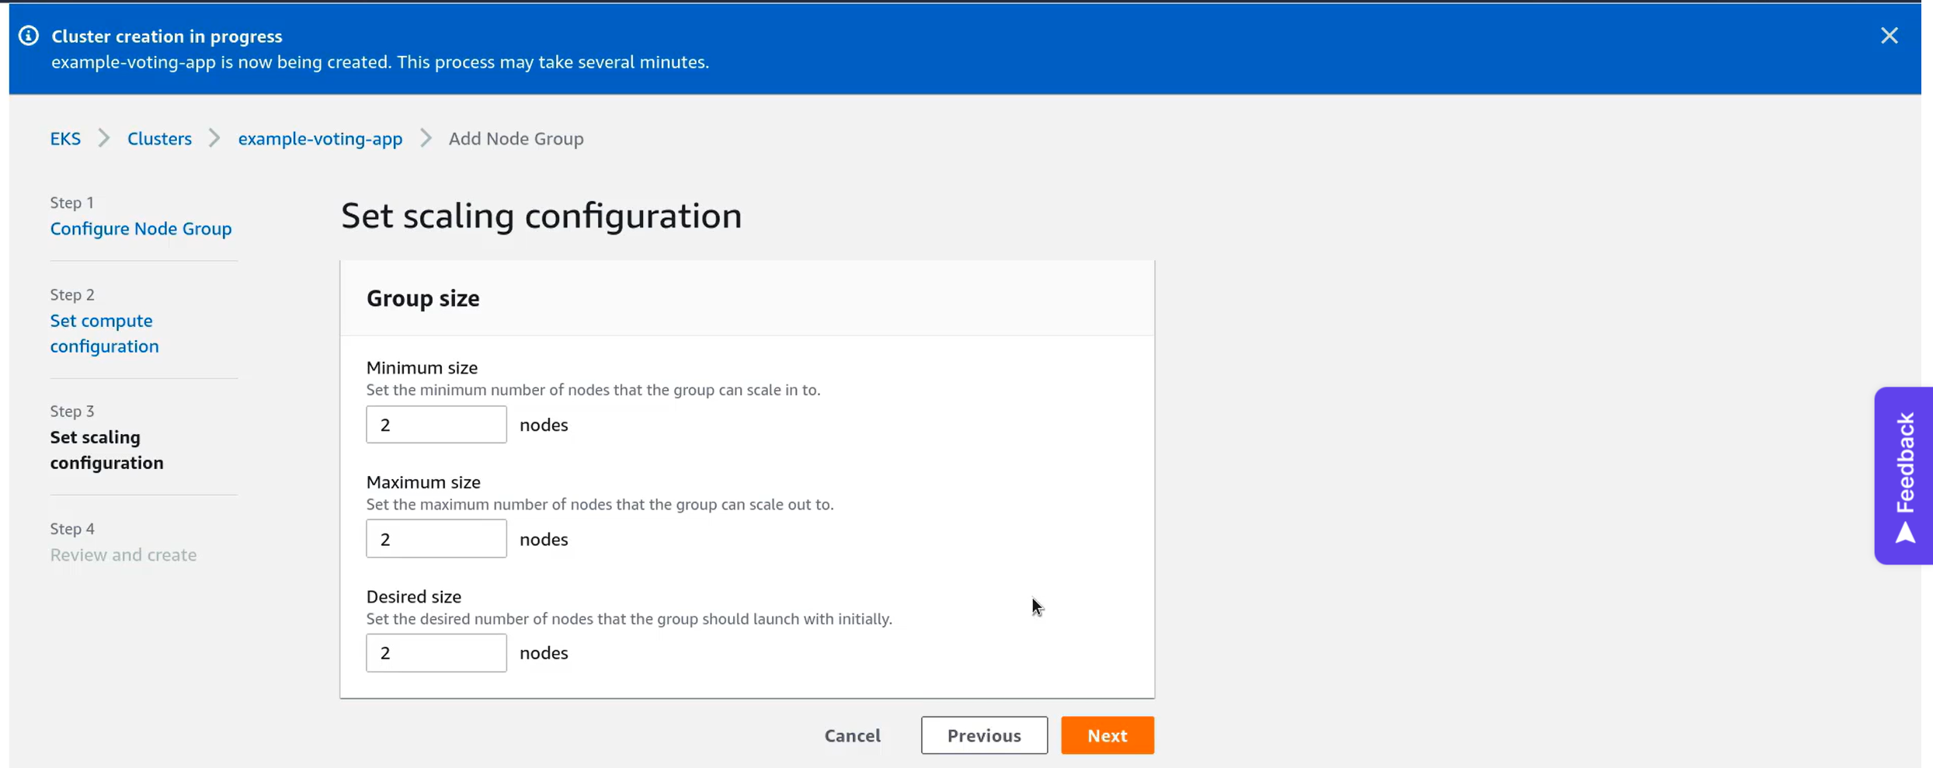Click on next and Click on Create this time.  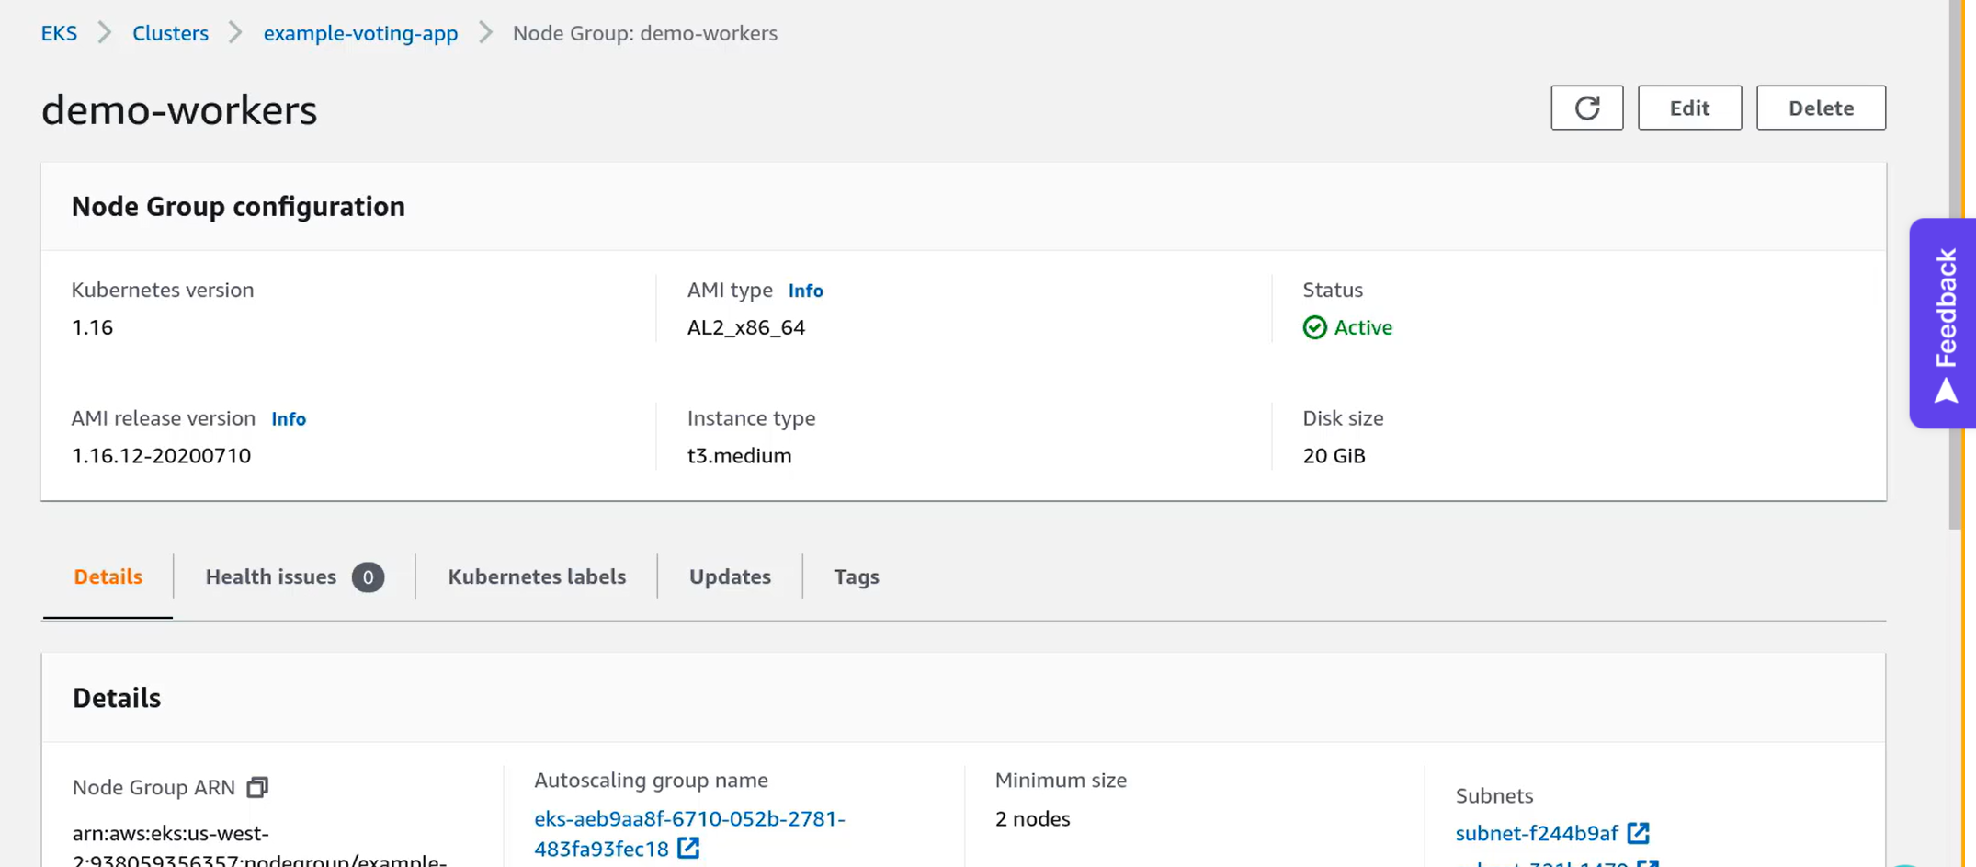 Now, node group is also active, now, we have to go to terminal and setup kubectl utility to access this cluster. But to do that before we need AWS CLI Installed and it is configured to our account. Install AWS CLI and configure your AWS Account from where you created EKS Cluster in your local system. Then run this command and add name of the cluster at the end of the command that you gave during cluster creation in AWS. 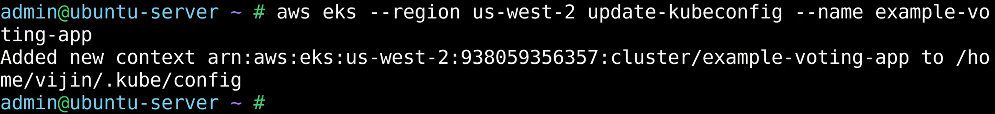To verify if it is working, give this command. 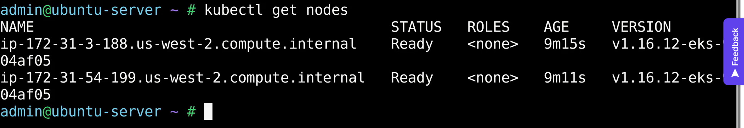You cannot SSH to the mster nodes or access them. In managed K8 services the master nodes are maintainer by service providers. Any kubectl command we run will be targeting the remote EKS cluster on AWS. Now, we are good go for our application deployment.

Go to GitHub repo and clone the repo: <https://github.com/kodekloudhub/example-voting-app> 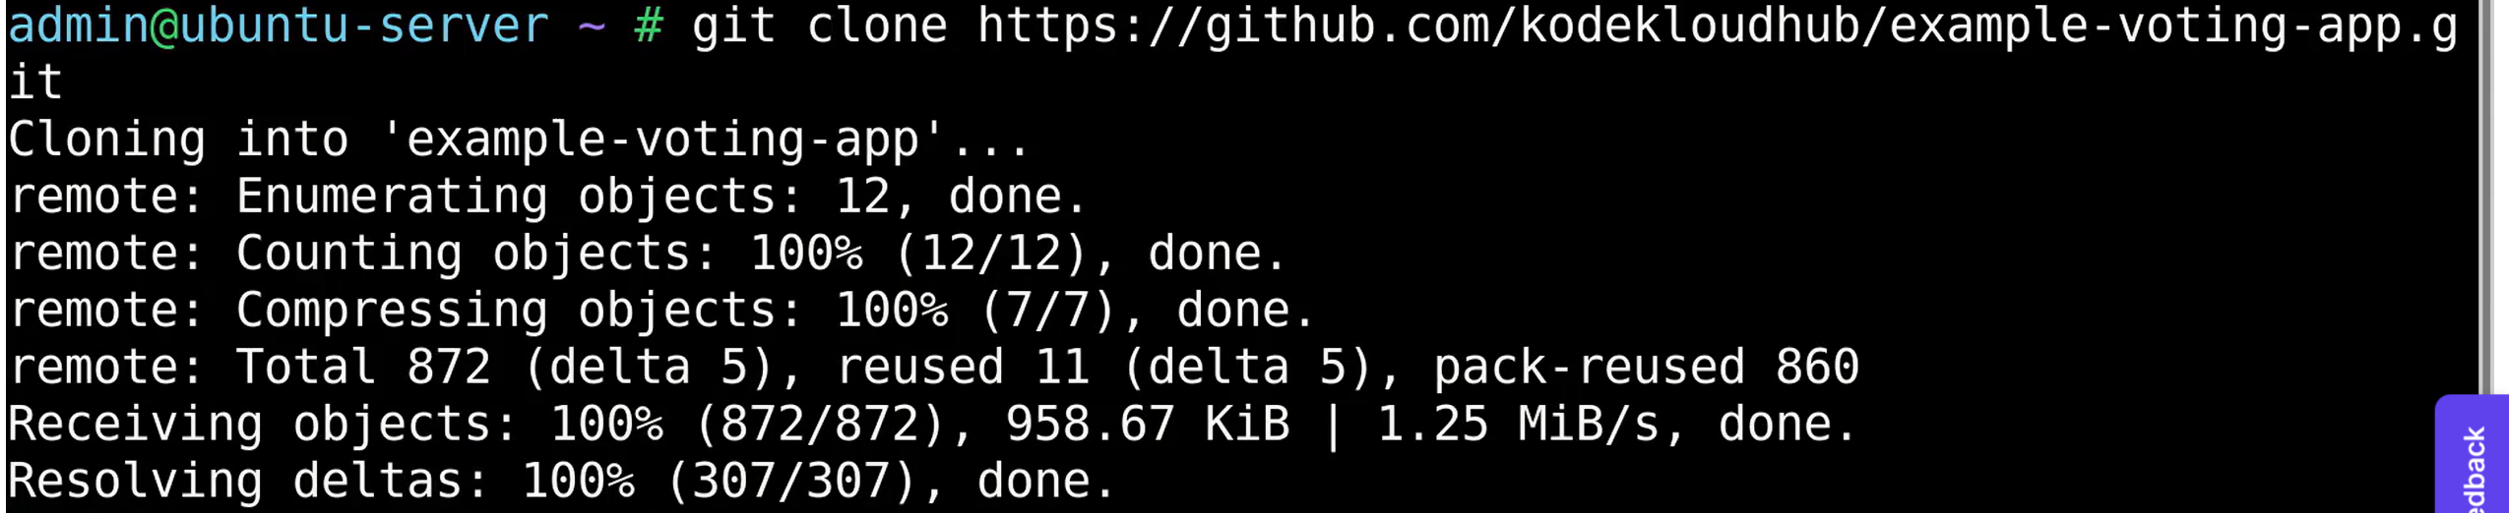Chnage the path: Let’s create the resources. 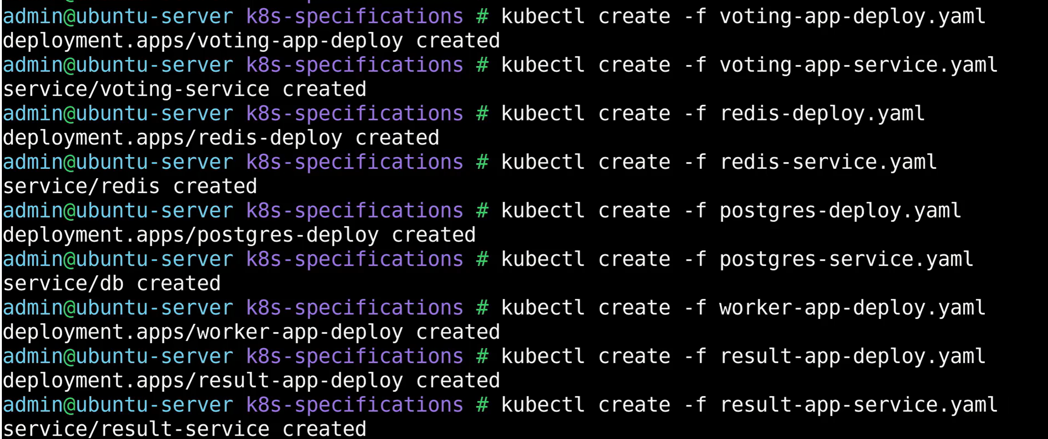Let’s check the status now. 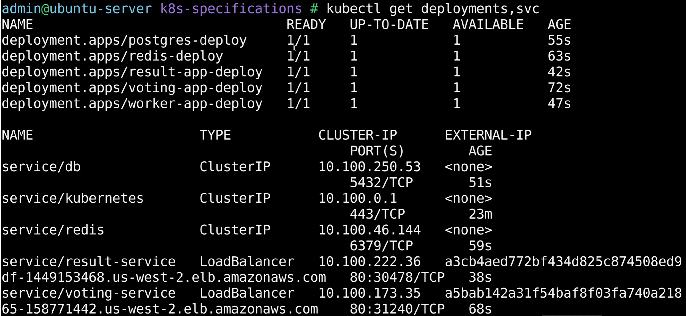All the pods are up and running. In the above pic you can see the External IP of Voting and Result apps. Copy them and open in new tabs in browser.

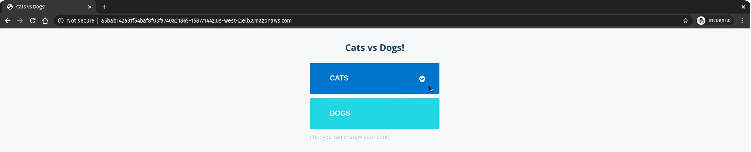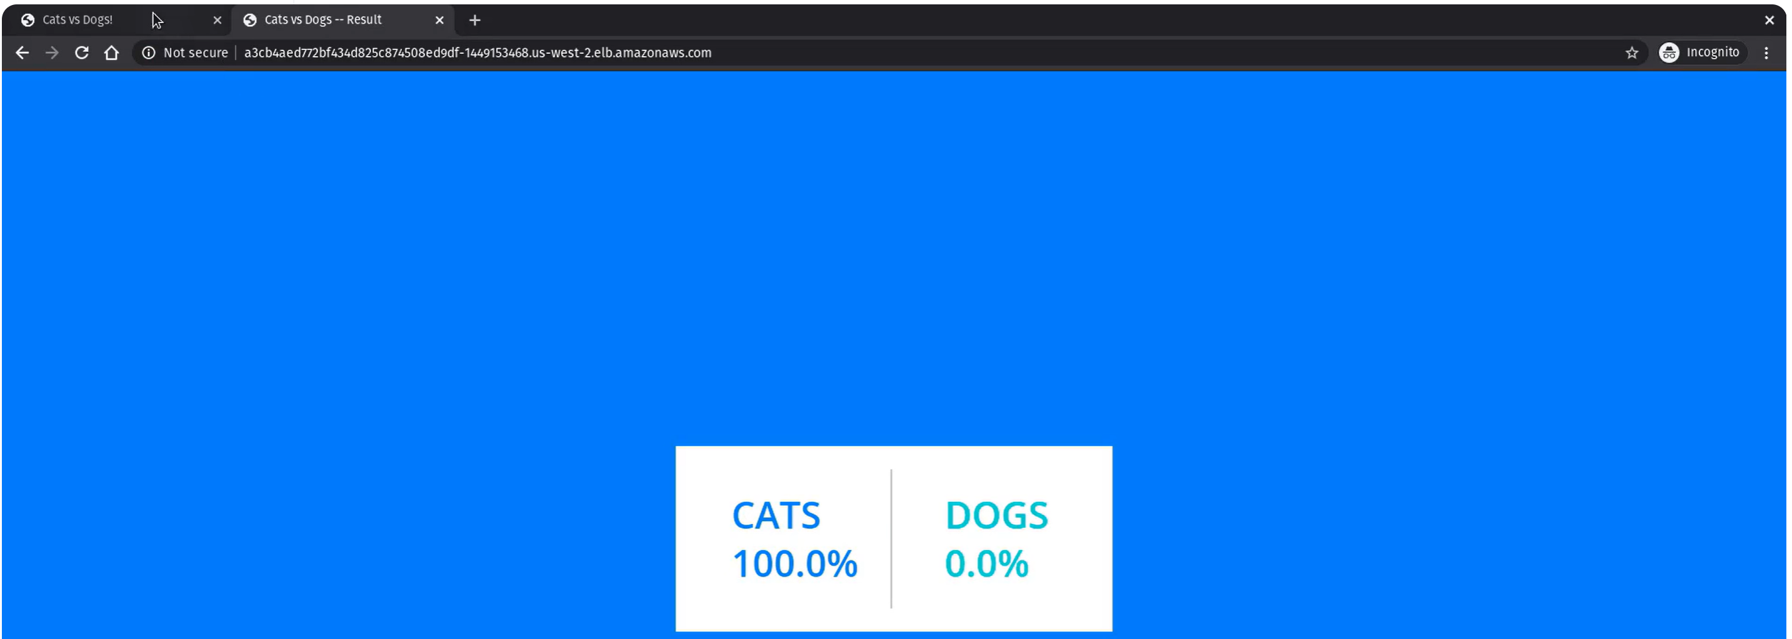Once it is done clean up everything to save from additional costs. Delete EKS cluster and any applications that you have deployed on that.

**Kubernetes on Azure (AKS):**

**Pre-Requisite:**

1. Azure Account.
2. Active Subscription.
3. Azure Basics.

Once we logged into the account it will look like this. 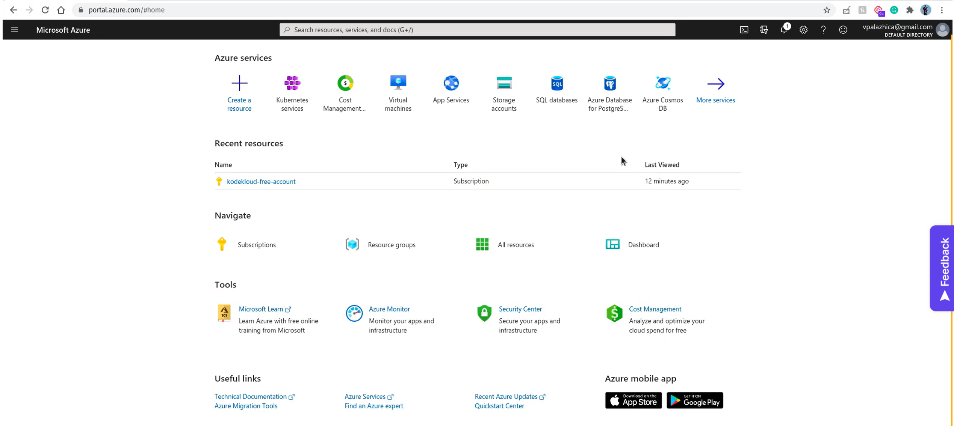Search for AKS 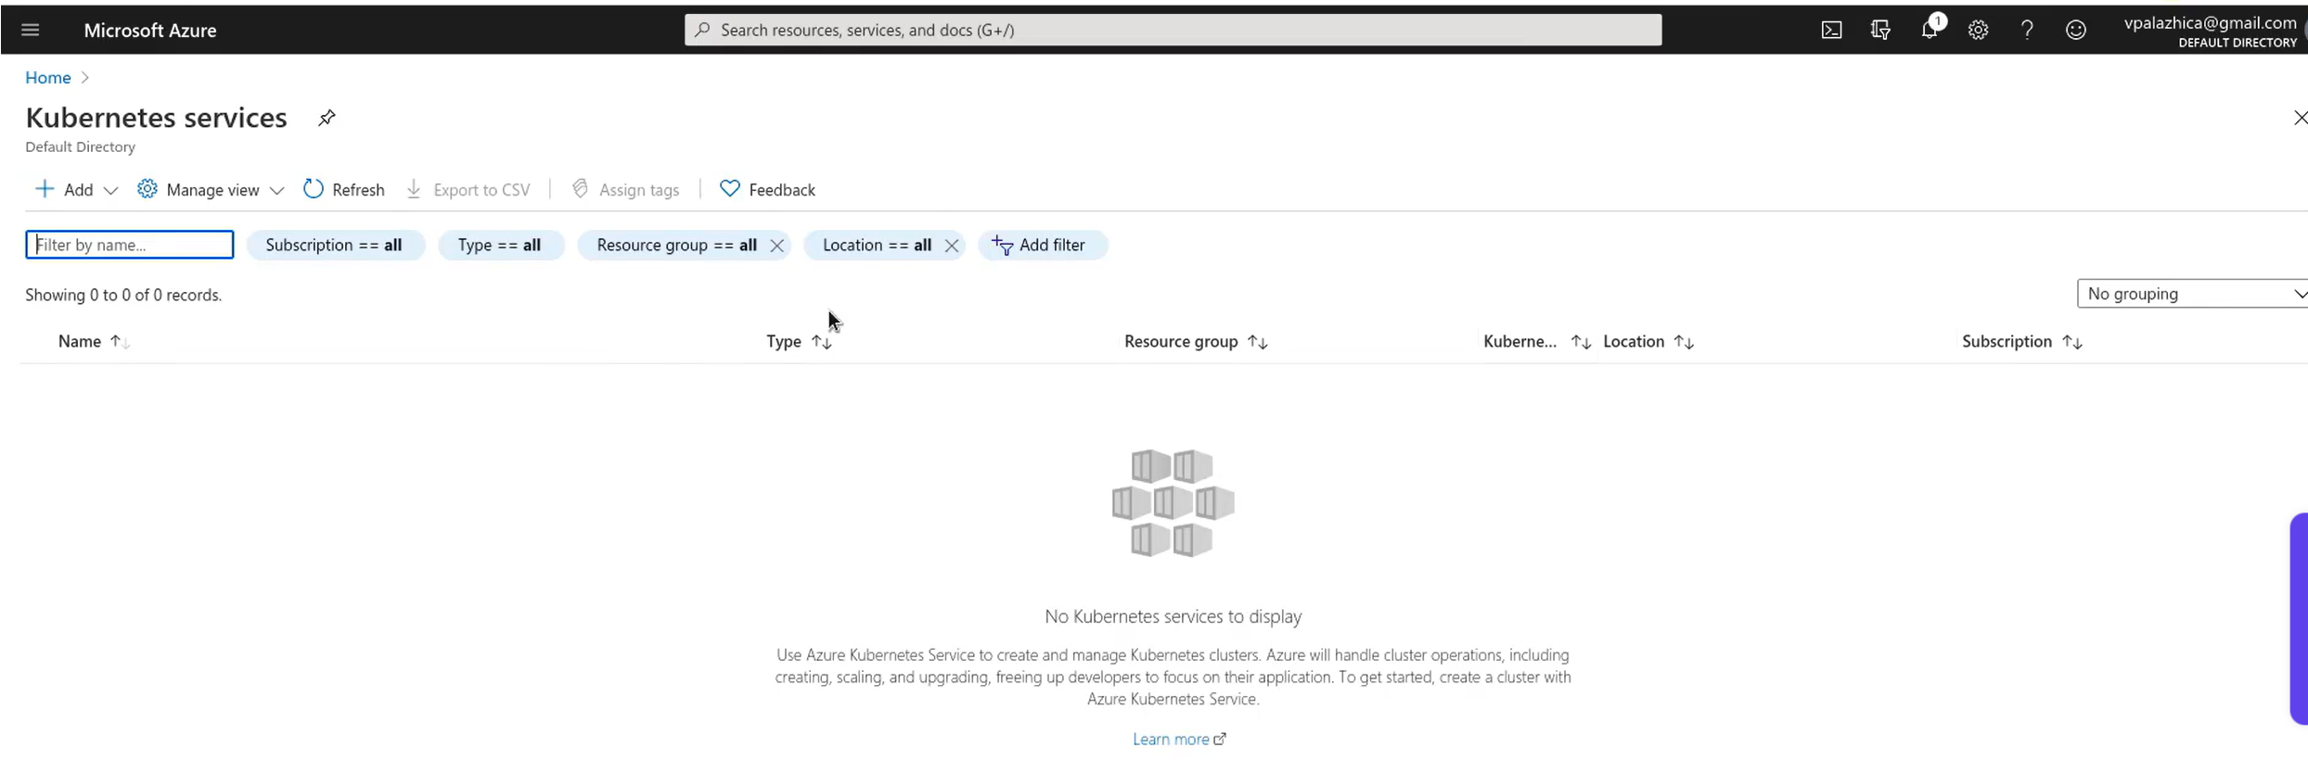First thing we need to do is adding a K8 cluster. Click on Add and then select Create Kubernetes Cluster. It take you to Create K8 cluster interface. 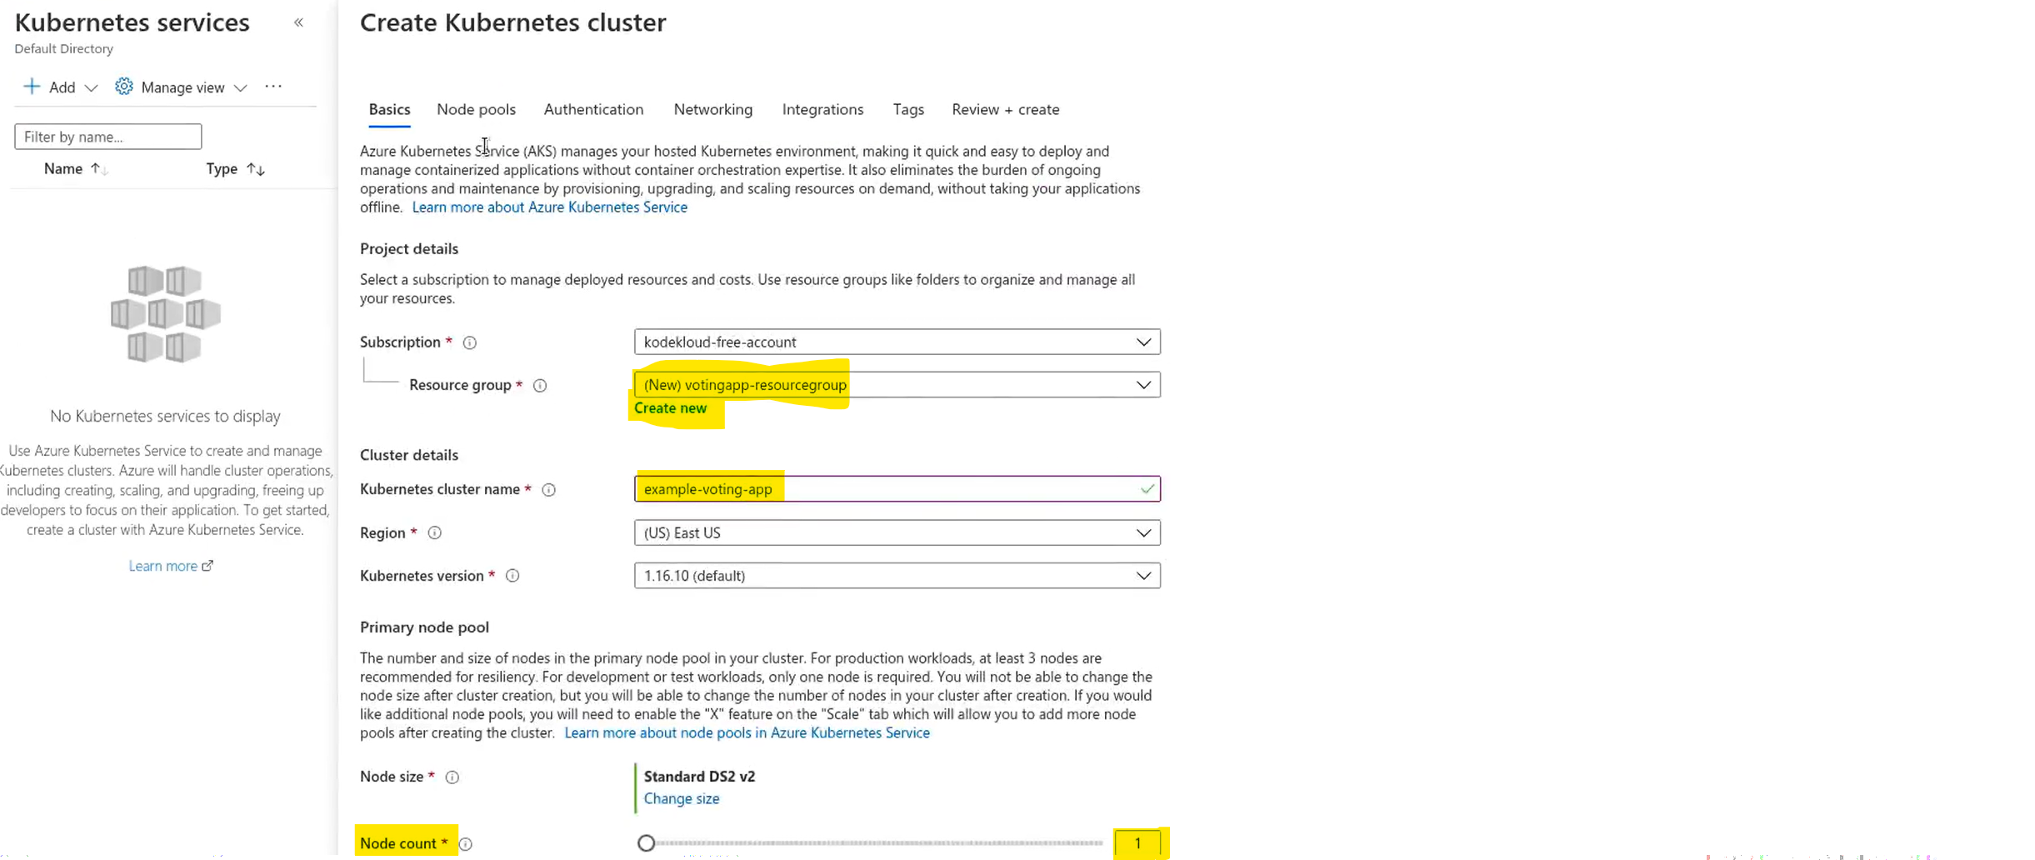Add Resource Group name, K8s cluster name and change node count to 1. That is enuf.

In Next Authentication section, use this. 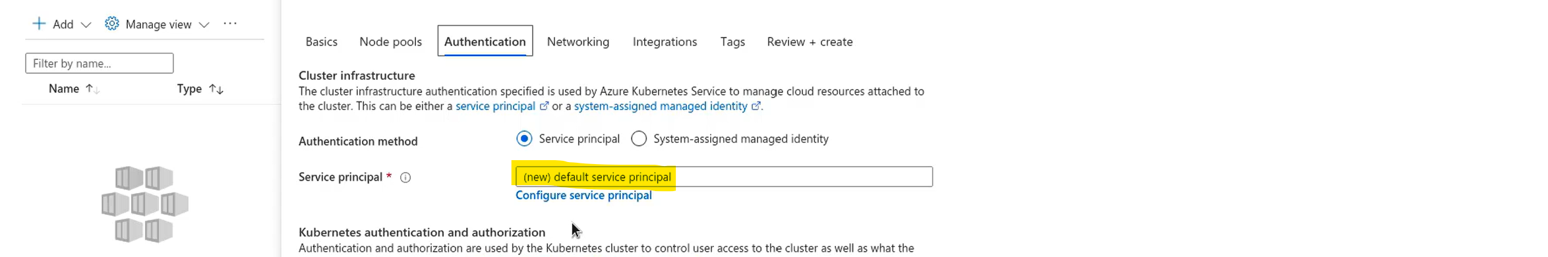It will be populating automatically, if not create a new one. Then click on Review and Create. Wait for few minutes to create the cluster. 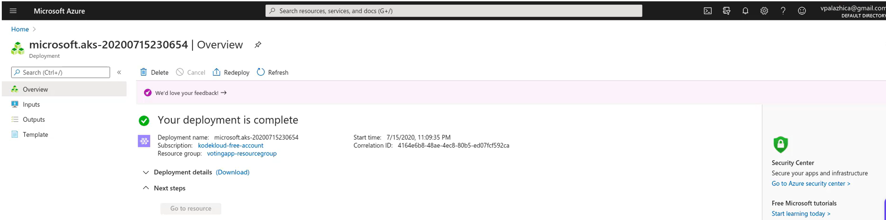Cluster is created. Go to the resources we just created. To go to the resource search for voting app in search bar. This is one way of accessing it.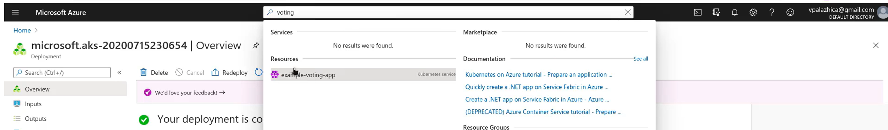To access the cluster we will use “cloud shell”. Right after search bar it is there. 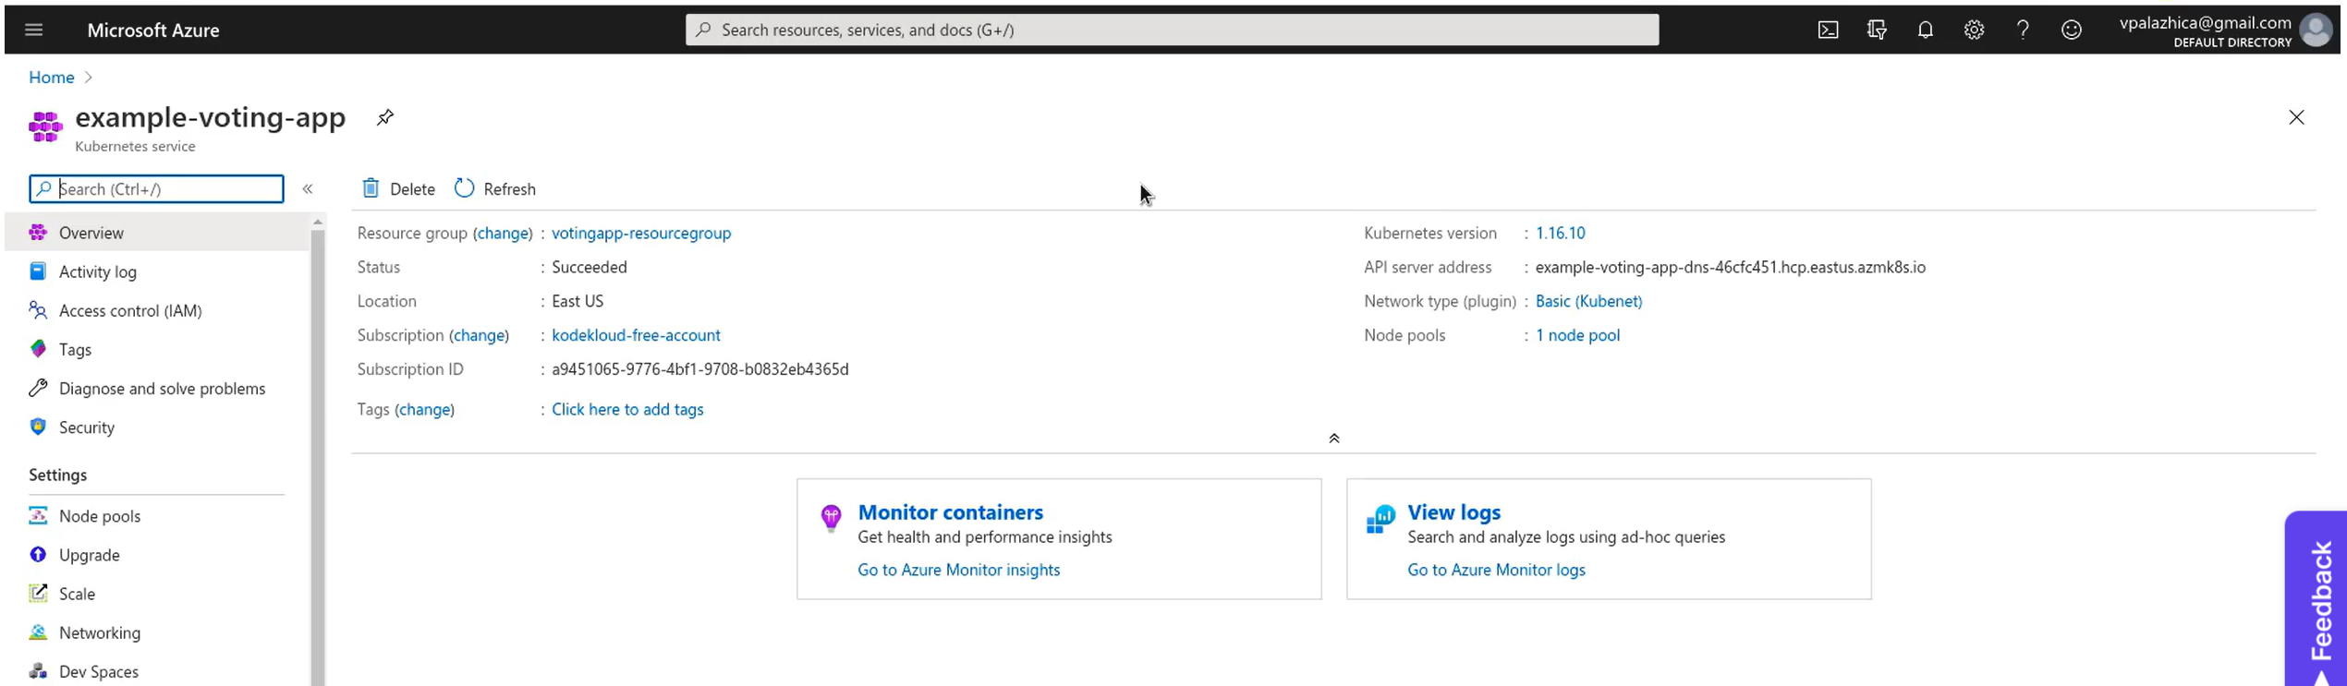Once you click on cloud shell, it opens up in the lower half of the screen. Drag it to the top for better view and usage. It is rompting to create storage for the cluster. 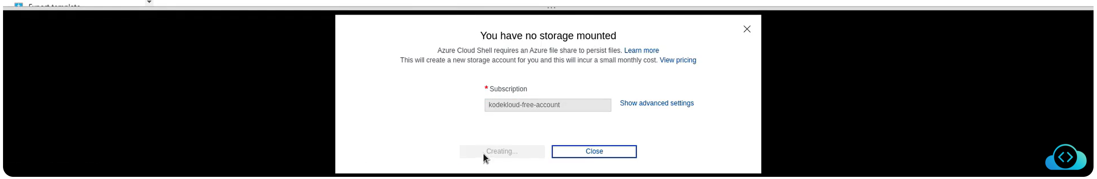Lets create storage. Close the prompt first.

And go through the documentation first: <https://learn.microsoft.com/en-us/azure/aks/learn/quick-kubernetes-deploy-portal?tabs=azure-cli>

Cloud shell is already installed with kubectl utility. Once the cloud shell is launched we need to grant access to kubectl to our AKS cluster. You need to give name of the resource group and cluster. Those names you find from below image.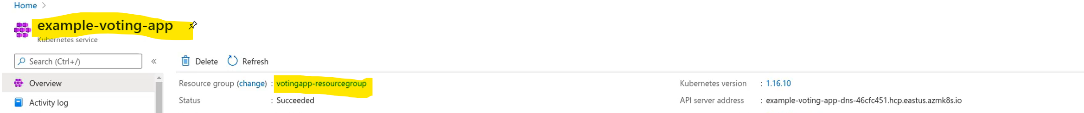

We can see our single node cluster. Clone the GitHUb repo of our voting app to get the K8s deployment and service YAML files.

GitHub Repo URL: <https://github.com/kodekloudhub/example-voting-app>

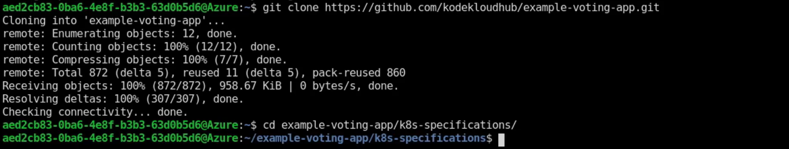Let’s start creating services and deployments. We will start with Voting app first. 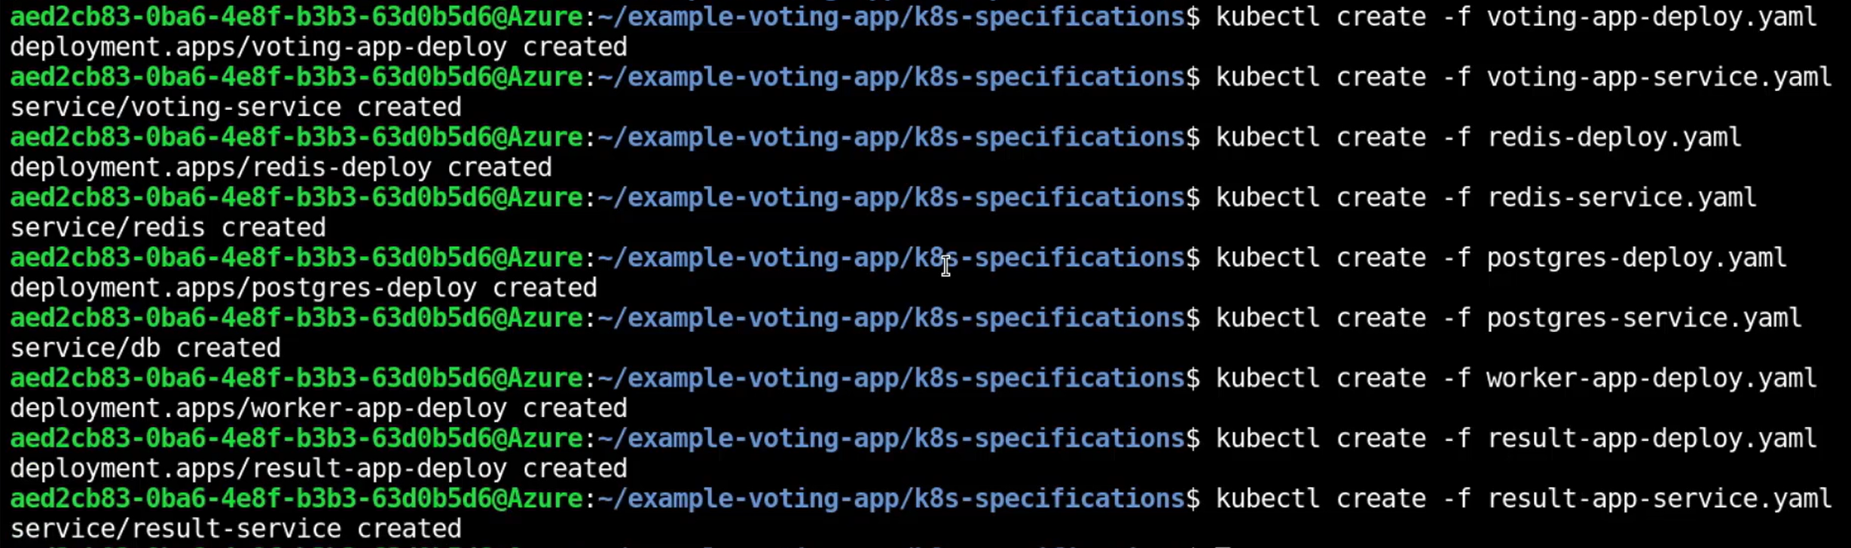All the deployments are done meaning one pod out of one pod are up and running and all the services are created and running.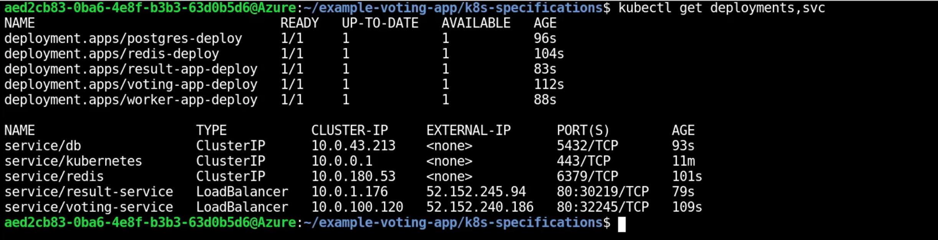Copy the External Ips of both voting and result service form the above picture and open in two different tabs of browser. 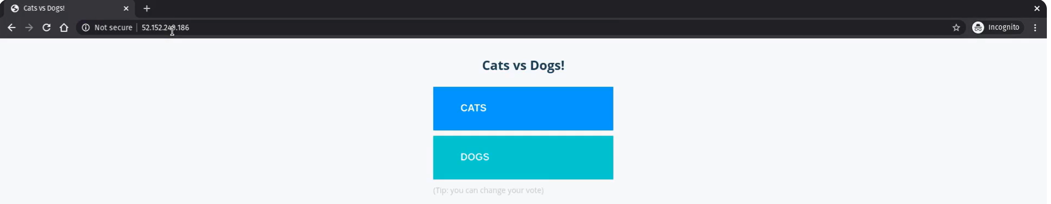

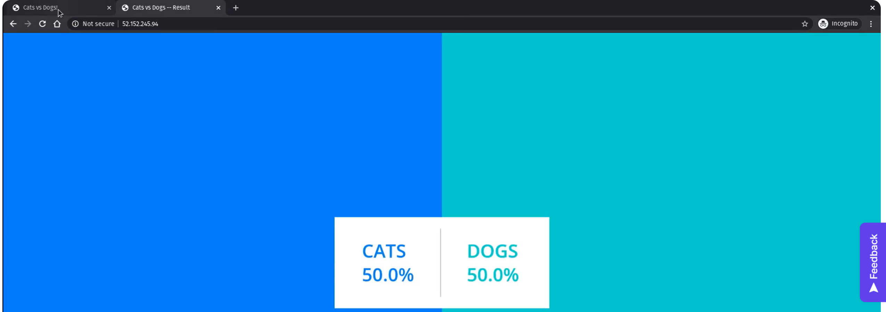

Now, caste the vote to any one.

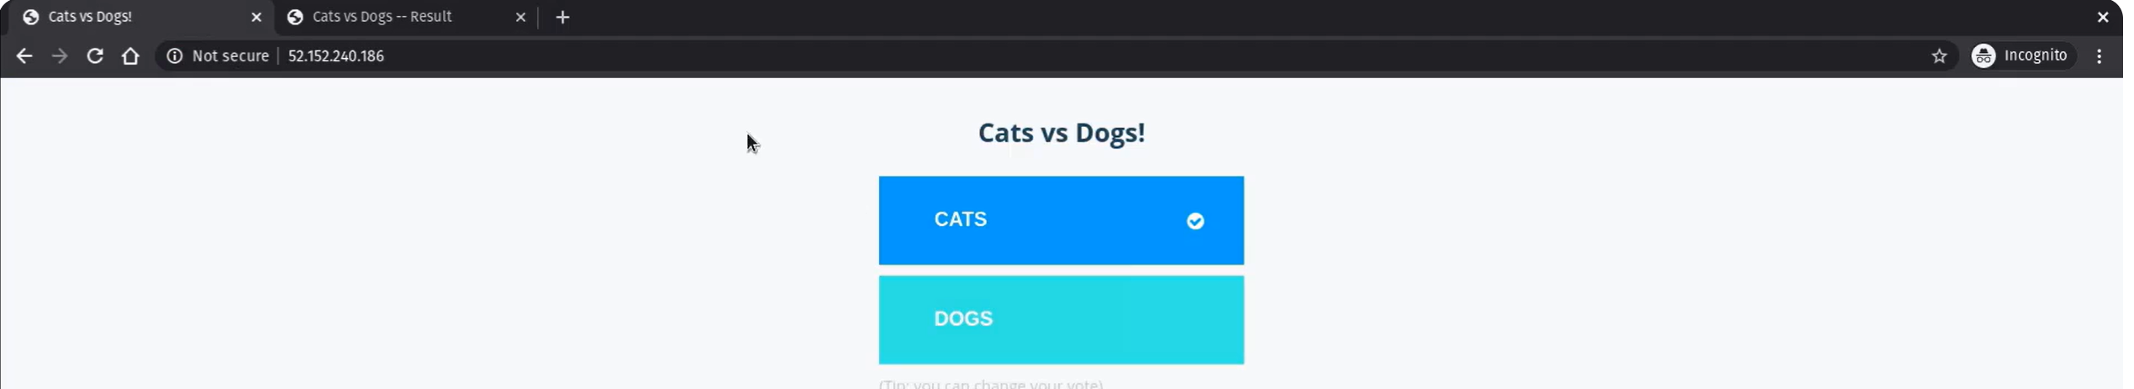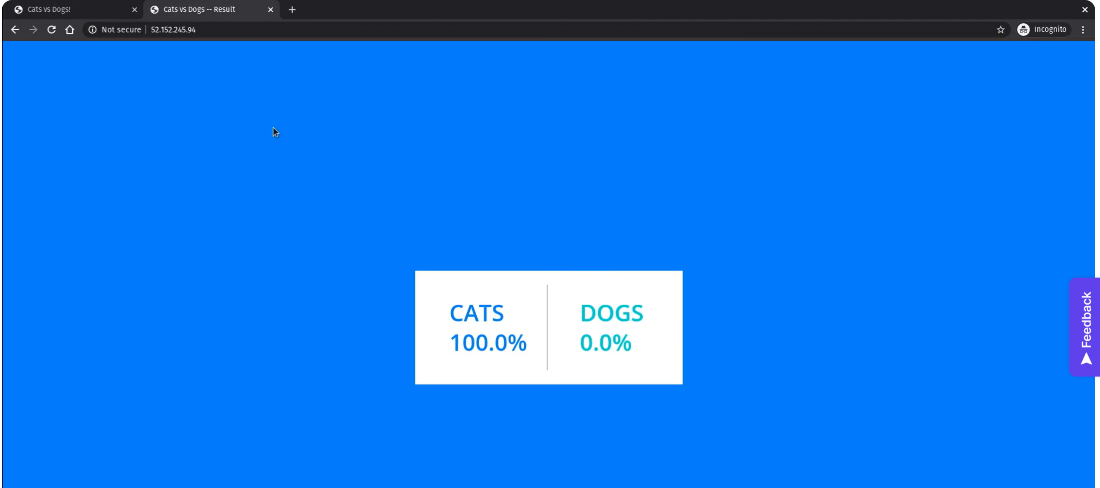Once done, remember to delete the cluster and clean up the workspace to save the credits.